FSE – Cleaning Guidance to Mitigate Legionella

Introduction and Purpose
This document provides guidance regarding the responsibilities and the practical steps to take to manage legionella risks associated with Faculty ‘owned’ equipment and any related pipework or system that connects to the water infrastructure.

What is Legionella?
Legionella pneumophila (and related bacteria) is a bacterium that can cause Legionnaires’ disease a form of pneumonia. Initial symptoms are flu like and may include high fever, chills, head and muscle pain. Infection is usually caused by breathing in small droplets of water contaminated by the bacteria. Although the disease can affect anybody some people are at higher risk e.g. those over 45 years of age, those suffering from chronic respiratory or kidney disease, and people whose immune system is impaired.
The Legionella bacteria survives low temperatures and thrive at temperatures between 20-45°C if the conditions are right, e.g. nutrients are present such as rust, sludge, scale, algae or other bacteria. Nutrients may accumulate if water is allowed to stagnate over time, e.g. during a campus closure.

Faculty, School, Institute and Department’s responsibilities
All the above have a specific obligation under the Control of Substances Hazardous to Health Regulations (COSHH) to assess the risk of exposure to substances hazardous to health with controls put in place to manage any foreseeable risk. This includes biological agents such as Legionella. Although the prevalence of Legionella bacteria is low, a system to manage potential exposure and any resultant ill-health should be in place.

Equipment and systems
Common laboratory items include (and not exclusive to): water baths, sonicators, rotary evaporator baths, incubators, lathes and machine tools that require coolants, and water purification systems.

What are the risk following campus closure?
The campus has been closed since the 17th of March. Therefore any systems containing water or fluids may have stagnated, sometimes in warm conditions, which in turn allows Legionella to grow and become a risk to those who use the equipment when we return to campus.

The steps below provide guidance on mitigating Legionella:

Item | Concern | Action
Fume Cupboard Taps / Sinks  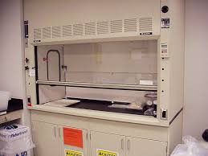 | Contamination of contained water in ‘dead leg’ elements | - If possible, attach a hose or piping securely to the tap leading into the sink to prevent splashes  - Ensure the fume cupboard sash is closed throughout  - Run slowly for a minimum of 2-3 minutes
Bench Sinks/ Hand Wash Sinks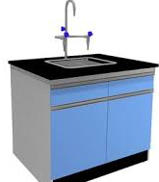 | Contamination of contained water in ‘dead leg’ elements | - If possible, attach a hose or piping securely to the tap leading into the sink to prevent splashes  - Stand away from the sink whilst the tap is running  - Run slowly for a minimum of 2-3 minutes
Emergency eye wash | Contamination of contained water in ‘dead leg’ elements | - Place shield over the static outlets (or place in sink if it is a hose) with a towel or bucket  - Run slowly a minimum of 2-3 minutes
Emergency showers  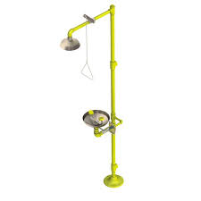 | Contamination of contained water in ‘dead leg’ elements | - Pull handle and move away from the area whilst the shower is running  - Run for a minimum of 2-3 minutes
Water Baths/ chillers and sonicators  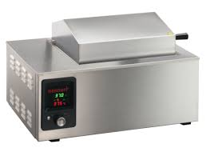 | Contamination of contained water | - Heat to 60°C for 1 hour (without using the sonicator function)  - OR make up 0.5% hypochlorite (i.e. bleach) within the bath and leave for 1 hour at room temp  - Slowly empty out decontaminated water into a suitable sink or drain (preferably in a fume cupboard sink) without making splashes  - Flush sink thoroughly afterwards
Water Purification Systems  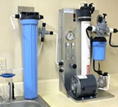 | Systems usually directly plumbed into the water system so minimal risk | - Consult manufacturer's instructions to sterilise system before use
Water Jacketed Incubators  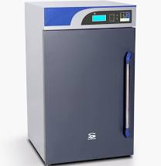 | Contamination of contained water | - Heat to 60°C for 1 hour  - OR make up to 0.5% hypochlorite within the tray and leave for 1 hour at room temp  - Slowly empty into a suitable drain (preferably a fume cupboard sink) without making splashes  - Flush sink thoroughly afterwards
Humidifying chambers  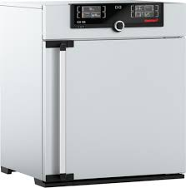 | Contamination of contained water | - Heat to 60°C for 1 hour  - OR make up to 0.5% hypochlorite within the bath and leave for 1 hour  - Slowly empty into a suitable drain (preferably a fume cupboard sink) without making splashes  - Flush sink thoroughly afterwards
Water Cooled Kit (recirculating)  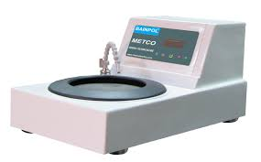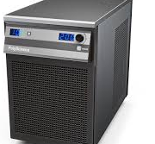 | Contamination of contained water | - Make up to 0.5% hypochlorite within the main chamber and leave for 1 hour at room temp  - Slowly empty into a suitable drain (preferably a fume cupboard sink) without making splashes  - Flush sink thoroughly afterwards
Metal working fluid used with lathes and machine tools  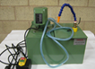  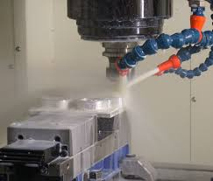 | Contamination of contained metal working fluid | - Any equipment containing metal working fluid, please consult Technical Operations/Services Manager  - Check metal working fluid for bacteria using dipslide testing. If test indicates bacterial growth ≥106 CFU/ml, draining and cleaning should take place  OR  - Assume bacterial contamination of all metal working fluid, draining and cleaning is required and follow manufacturer’s instructions
Large water tanks  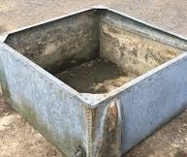 | Contamination of contained water | - Consider contractor to disinfectant and decontaminate tank
Hose Reels  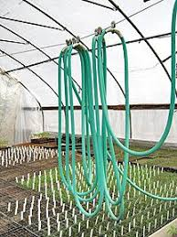 | Contamination of contained water in ‘dead leg’ elements | - Ensure connections are secure and aim hose into drain or sink to prevent splashes  - Run slowly a minimum of 2-3 minutes

