|  |
| --- |
| Artem Mishchenko **E** B.06 0161 306 6575 |
| Darren Shepherd  G.26 0161 275 4061 |
| Nicola Hutchings  G.51 0161 275 4088 |
| Adam Lacey **E** G.53 0161 529 3992 |
| Alan Wardle 1A.05 0161 275 4079 |
| Doudou Pan **E** 1.61 0753 697 3485 |
| Alex Mason 1.61 0161 306 6464 |
| Aleksander Kedziora 2.08 0794 046 8625 |
| Simon Carroll **E** 2.51 0161 306 6465 |
| Artem Mishchenko **E** 2.18 0161 306 6575 |
| Hayley Markham **E** 2.55 0774 117 1876 |
| Giles Edwards 4.08 0795 897 7798 |
| Jesus Carlos Toscano 5.63 0161 275 4183 |
| Michaela Queitsch-Maitland **E** 6.18 0734 046 5327 |
| |  |  |  |  | | --- | --- | --- | --- | | |  | | --- | | Slawek Kubecki **E** 6.20 0192 560 3995 | | Francisca Munoz Sanchez 5.07 0161 275 4117 | | Joleen Pater  5.10 0161 306 6479 | | |
| |  | | --- | | Francisca Munoz Sanchez **E** 6.20 0161 275 4117 | |
| Alexander Bitadze **E** 6.22 0758 670 6914 |
| Robert Chapple **E** 6.22 0161 306 6477 |
| |  | | --- | | Hesham El Faham 6.56 0749 825 9580 | |
| Rob Appleby **E** 7.09 0161 275 4223 |
| Can Davut **E** 7.25 0740 4936 709 |
| Theodore McKeever 7.26 0781 782 6742 |
| **E** = emergency one day course |
|  |

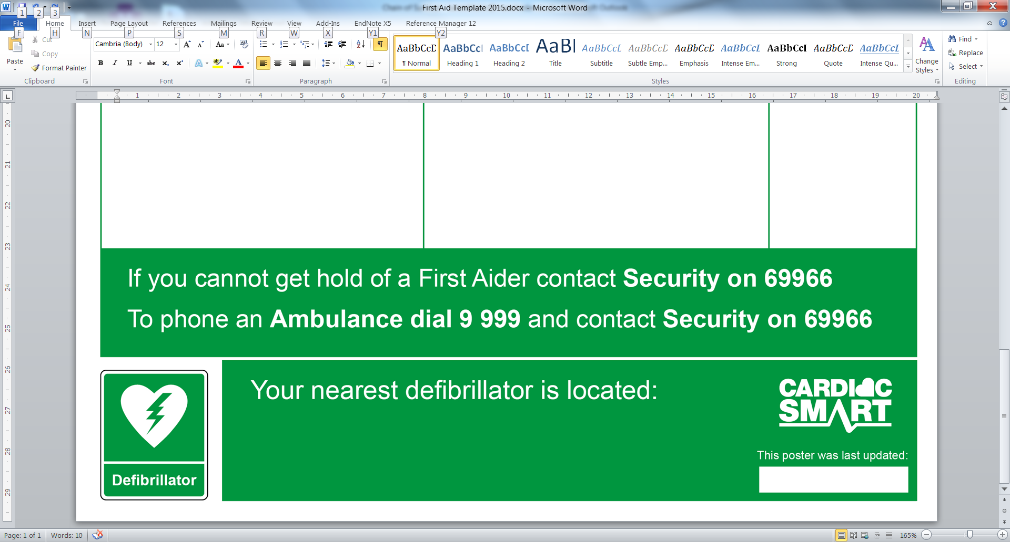

at the building reception desk

-24

**This poster was last updated on:**