Storage and Segregation of Hazardous Chemicals

Recent inspections and incidents in labs, workshops and other areas, have highlighted a continuing need to be vigilant when storing hazardous chemicals. This must be managed and items segregated and stored safely by implementing the principles outlined below.

Risk assess chemical usage
Before ordering chemicals a chemical risk assessment (CRA) for the use of the chemicals MUST be in place. The RA process should consider and state any specific requirements for the below:-
- Can the task be done or adapted so that does the chemicals are not required?
- Can the chemicals be swapped for less hazardous materials or a more dilute version?
- Are suitable storage arrangements in place?
- Will the chemical change the risk profile of the work space?
- Could small amounts be borrowed from another local user – check the LabCup inventory?
- Have disposal requirements been considered?
- Is the facility suitable for the chemical with emergency and spillage controls in place e.g. use of hydrogen fluoride requires specific first aid arrangements to be in place PRIOR to use?

Basic principles of storage
- Create and maintain an inventory of chemicals in each location e.g. LabCup
- Keep stock to a minimum, only order the lowest quantity required
- Store chemicals in original containers
- Check the label, ensure self-made labels are legible, stating the hazard group and owner
- Dispose of out-of-date, or redundant stock (via hazardous waste disposal route or see Estates A to Z of recycling for non-hazardous wastes. Only re-use containers for similar waste after rigorous flushing and ensure the label clearly states that the container now holds waste.
- Store and segregate chemicals by the primary hazard category – consult safety data sheets (SDS), using storage cabinets where needed. In brief:-

What to segregate
Store like with like, segregate most hazard categories:-
- Flammables from non-flammables
- Always separate halogenated solvent from acids, bases, flammables and non-halogenated solvent
- Halogenated solvent from non-halogenated solvent
- Flammables from alkalis (bases) and acids.
- Always check the SDS -some organic acids are flammable e.g. formic acid and acetic acid, these must be stored in the flammables cabinet not in the acid storage
- Alkalis (bases) from acids
- Organic acids from inorganic acids
- Oxidising agents from most other types of chemical especially flammables
- Very toxic from everything else e.g. mercury, HF
- Most categories will have a designated cabinet e.g. flammables, acids or very toxic, otherwise secondary containment and/or bunding - where trays are used to achieve separation by distance can be considered.

Segregation of Incompatible Chemicals
Segregation of hazardous substances by primary hazard classification and separation from incompatible chemicals using storage cabinets, secondary containment or distance will minimise the likelihood of accidental adverse reactions and exposure (Appendix 1 & 2). To avoid accidental mixing of incompatible chemicals, substances should be stored in securely closed containers and cabinets which, are specifically designed for the purpose and clearly labelled.

The table below summarises the main requirements:-

In General, (X = incompatible)

 | Flammable Liquids  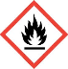 | Inorganic Acids  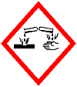 | organic Acids | Alkalis / Bases | Oxidising Agents  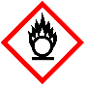
Flammable Liquids  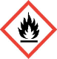 |  | x |  | x | x
Chlorinated solvent  e.g. chloroform | x | x | x | x | x
Inorganic Acids | x |  | x | x
Organic acids* |  | x |  | x | x
Alkalis / Bases | x | x | x
Oxidising Agents  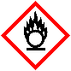 | x |  | x
Storage of flammable liquids in containers HSG51
Caution: Not all hazardous substances follow general guidelines, always consult the safety data sheet.

Primary Hazard Categories Storage
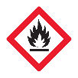Flammables
Substances categorized as highly flammable or flammable support combustion if an ignition source and oxygen are present.

A maximum of 50L of highly flammable liquid can be stored in a well ventilated area. Flammables must be stored within a metal fire rated flammable cabinet. Flammable waste, where possible, should be stored in a separate flammable waste cabinet.

Flammable cabinets must be of metal design and provide at least 30 minutes fire resistance, recently purchased cabinets should conform to BS EN 14470-1:2004.
- Flammable cabinet storage incorporates a bund /sump tray with the capacity to hold 110% of the largest container of stored liquid if there is a leak.
- Do not store flammables with incompatible items (see compatibilities table above).
- Flammable cabinet positioning must be carefully considered. Located away from room exits, evacuation routes and ignition sources.
- Record flammable storage location and amounts stored on area fire risk assessment (inform safety office).
- Flammable storage cabinets must be correctly labelled with the flammables sign and lockable.

Examples of suitable signage and flammable cabinets:-

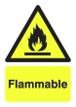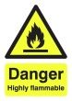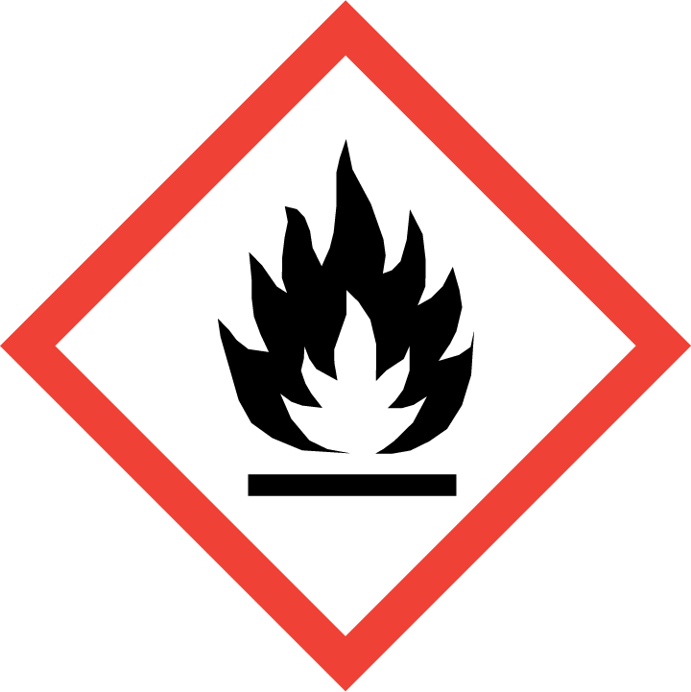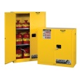

Acids or Alkalis
Acids and alkalis are corrosive; contact will destroy human tissue e.g. the skin or eyes. Many concentrated acids also release corrosive vapours which, if inhaled, can lead to respiratory damage.

Acids and alkalis must be stored in separate corrosion resistant cabinets. Organic and inorganic acids are incompatible and should not be stored together.
- Store acids and alkalis in a well ventilated area.
- Cabinets must have bunded shelves to contain spills if containment fails.
- Always store acids and alkalis below shoulder level to minimise splashes to the face and eyes.
- Corrosive cabinets must display acids / corrosives signage.
- Always consult the data safety sheet as there are exceptions; glacial acetic acid should be stored with flammables as it is combustible as well as corrosive.

Concentrated nitric acid must be stored away from other concentrated acids in designated storage. Nitric acid should be disposed of via the hazardous waste route prior to the expiry date to minimise likelihood of deterioration and failure of the plastic bottle it is kept in. LabCup can be set up to warn of an upcoming expiry date.

Hydrofluoric acid (HF) should only be stored in a screw capped polyethylene bottle (or equivalent) containers in a cool well-ventilated area. (HF attacks glass, concrete and some metals.) Stock solutions of HF must be stored in a locked cabinet and the lab must have restricted access.

Examples of suitable signage and corrosive cabinets:-

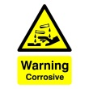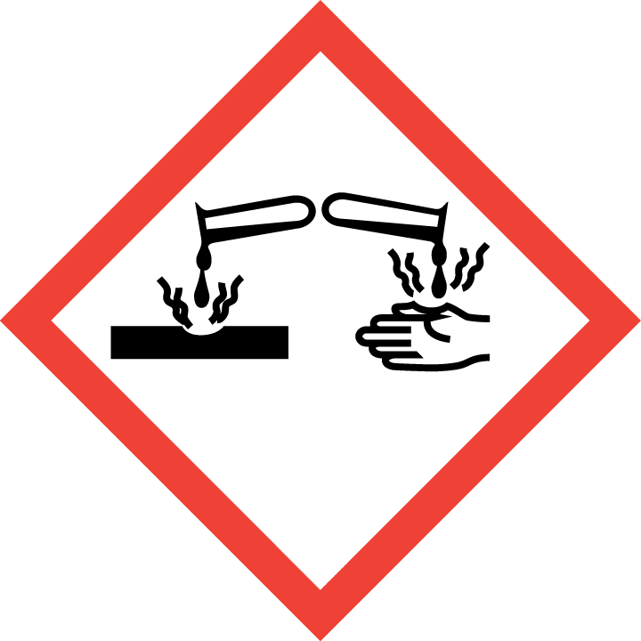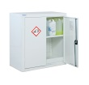

Oxidising agents
Oxidising agents are generally highly reactive chemicals which if stored inadequately could propagate fire.

Always segregate oxidising agents from flammable or combustible materials
- Locate away from main evacuation routes.
- Store in a cool, dry location using clearly labelled lidded containers and/or trays.
Examples of suitable signage and secondary containment:-

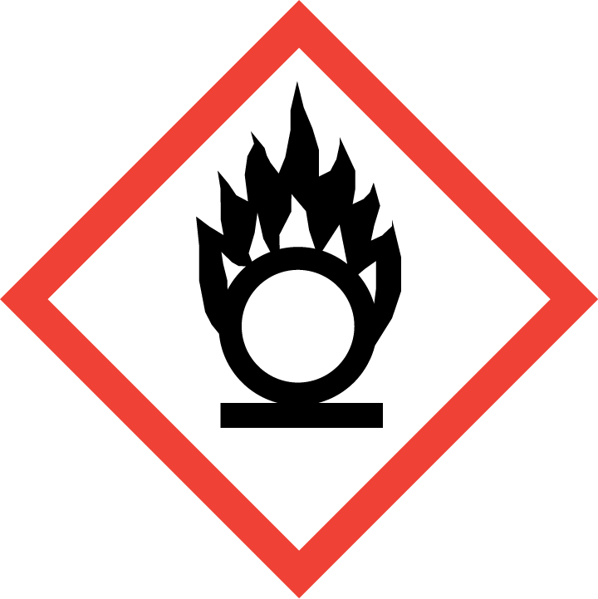

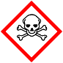 Poisons, Carcinogens, Mutagens, and Reproductive toxins (CMRs)
- Must be segregated and stored securely preferably in a locked metal cabinet that is clearly labelled.
- Clearly label and store in lidded containers as secondary containment within the cabinet.
- Only authorised people should have access.
Lockable metal poisons cabinet
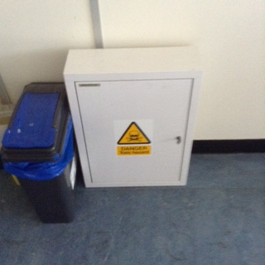

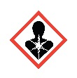Chlorinated solvents often CMRs
Chlorinated solvents such as chloroform should be stored separately and segregated from flammable solvents.
• Segregate from flammable solvents and alkali metals.
• Store in vented cabinet, clearly labelled metal cabinet and/or lidded containers and/or trays.
• Chlorinated solvent waste must always be segregated from non-chlorinated waste.

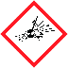Peroxides and Explosives
Peroxides are heat and shock sensitive.
- Segregate and store in dedicated cupboard/area located in a temperature stable environment.
- Regularly dispose of any out-of-date peroxides via hazardous chemical disposal route.
Some non-peroxide chemicals such as diethyl ether form explosive peroxides when exposed to oxygen.
- Dispose of out of date peroxide forming chemicals.
- Always consult the safety data sheet.

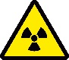 Radioactive material
Radioactive material is required to be stored safely in a secure location, i.e. in a locked laboratory that has limited or restricted access. The Radiation Protection Supervisor (RPS) or responsible person will supervise and advise on the safe storage of material.
- Contact RPS before purchasing or acquiring any radioactive material.
- When not in use sealed sources should be kept in containers with suitable shielding where necessary - the original container is usually adequate for this.
- Storage of radioactive material should be in a secure location, i.e. in a locked cupboard in a locked laboratory.
- Storage locations must be registered with the RPS.
- Radioactive material must be segregated from any corrosive, explosive or flammable material.
- All storage containers / cabinets must be labelled as radioactive.

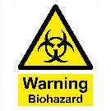Biological agents/material
Biological agents such as viruses, bacteria and fungi should be stored and handled in line with the specific biological safety level.
- Identify all samples and bio materials with labelling which will withstand storage conditions.
- Store bio samples in accordance with the bio safety level, supplier and Bio Safety Advisor (BSA) advice.
- Fridges or freezers should be used solely for bio sample storage and labelled as such.
- Where stored under liquid nitrogen / cardice, refer to cryogenic storage local guidance.
- Refer to BSA for further information.

Other common” storage” areas

Ventilated Cabinets
These are cabinets with ventilation and may be free standing with their own extract system or positioned beneath or alongside a fume cupboard and attached to its ductwork. The majority of fume cupboards have cupboards below them most of which are NOT ventilated. Please check if ventilation is provided by contacting the Technical Operations Manager in the area.
Ventilated cabinets are designed to safely store chemicals that give off noxious fumes and odourous smells. The fumes are extracted away from the user. They are provided to be used to store chemicals such as mercaptans and amines that have a strong smell, and lachrymators. If there are no ventilated cabinets available, the next best option is to store the primary chemical container in a sealed secondary container (secondary containment) which must only be opened in a working fume cupboard.

Fume cupboard storage
Fume cupboards are neither designed nor intended for the storage of chemicals. The working surfaces of fume cupboards should be kept clear of materials and containers when these are not needed for the ongoing work activities. Excess storage of chemicals (including adding extra shelves) in fume cupboards disrupts the airflow and results in a lower level of protection to the users. Chemicals should be returned to the designated storage area after use.

Lab shelving and general cupboards
Many areas are store non-hazardous chemicals on open shelving in labs and storerooms. This is often done by arranging chemicals alphabetically from A to Z. This is not suitable for hazardous chemicals as this may place chemicals alongside other chemicals which, in the wrong circumstances, may result in an uncontrolled reaction.
Solid hazardous chemicals must be segregated in the same way as liquids. The use of clearly labelled lidded plastic boxes, which can be identified by location in the LabCup inventory, has proved successful and also improves housekeeping issues.

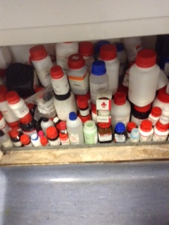
Example: how secondary containment can aid storage:-

Out of date chemicals, degraded/damaged containers and labels
It is important to routinely check the viability of chemicals and containers. Out-of-date chemicals and damaged containers can lead to unwanted, accidental reactions and exposures. A chemical management system such as LabCup is an effective way of maintaining control. Always seek advice when a loss of containment is discovered to enable it to be dealt with proportionately and safely.

Fridges and freezers
Fridges and freezers may be needed for the storage of certain hazardous substances, only equipment fit for purpose and designed for the hazard group being stored should be used. This should be included in the RA for the area.
For example; if a flammable substance must be stored below ambient temperature a specifically designed fridge suitable for such, normally referred to as “spark proof” must be used. Fridges and freezers are a closed environment; a stored flammable substance could lead to an explosive atmosphere hence the need for a spark proof fridge. Flammables should be contained within the fridge in closed containers and to aid retrieval consider separation using plastic tubs.
Segregation of incompatible substances must still be upheld, labelled secondary containment is useful to achieve this. Remember to consider how to safely transport and retrieve items from the fridge and consider if other users may have stored incompatible materials. Fridges and freezers etc. should be included and should be included in the LabCup inventory.
Fridges and freezers must be correctly labelled with an appropriate external signage. Items within fridges and freezers should be trayed.

Useful Resources
Free sign making Selection of safety signs create bespoke signage for chemicals and chemical storage

Safety cabinets A number of suppliers in eMarketplace

Safe Use and handling of flammable liquids HSG140

Storage of flammable liquids in containers HSG51

Safety signs and signals. The Health and Safety (Safety Signs and Signals) Regulations 1996. Guidance on Regulations L64 (Third edition) HSE Books 2015 ISBN 978 0 7176 6598 3 www.hse.gov.uk/pubns/books/l64.htm

BS EN ISO 7010:2012 Graphical symbols. Safety colours and safety signs. Registered safety signs. British Standards Institute

Appendix 1:
Chemical Storage – Do’s, Don’ts and Why Not’s?

This information is for guidance. Always refer to the SDS for specific storage information.
DO NOT…. | WHY? | DO…
Store acids and bases with solvents.  Put acids and bases in solvent waste containers. | Acids and bases react violently with solvents creating heat, gas and often toxic products.  Putting acids and bases in solvent waste could cause waste containers to explode. | Store acids and bases in suitable metal cabinets, which are clearly labelled.
Store acids and bases together. | Acids and bases can react violently together. | Store acids and bases separately.
Store oxidisers with flammables. | This will accelerate combustion if a fire were to occur. | Store oxidisers and flammables separately.
Store peroxides with flammable solvents. | Peroxides can form explosive materials if they come into contact with solvents. | Store peroxides in a cool environment e.g. fridge or cold storage.
Store acetic acid or acetic anhydride with other acids. | They are highly flammable and will react violently with acids (especially nitric acid). | Store as organic solvent rather than as corrosive substances.
Store pyrophoric substances with flammable solvents. | One is an ignition source the other is a fuel thus combustion is likely on mixing. | Store pyrophoric materials in separate flame proof containers (they are often stored under inert gases but refer to the SDS for specific information).
Mix waste chemicals in the same storage containers. | Mixing two or more waste chemicals can cause violent reactions (e.g. chloroform and acetone, or methanol and sodium hydroxide). | Store flammable waste solvents separately from chlorinated solvents. Halogenated solvents are typically not flammable and do not need to be stored in a flammables type cabinet.
Store dry ice (cardice) in sealed containers. | The carbon dioxide gas released will over-pressurise a sealed container causing an explosion. | Leave unwanted dry ice in a fume hood to evaporate naturally.
Store waste in unlabelled or poorly labelled containers. | Proper labelling minimises the risk of misuse or mishandling of chemical substances, reducing the likelihood of injury. | Clearly and accurately label all chemical storage containers with contents and hazards.  Arrange disposal regularly.
Store chemicals near heat or flames. | This is likely to cause a fire or explosion. | Keep heat sources and flames well away from chemicals.
Store large quantities of solvents and other hazardous chemicals. | Increases the risk of fire, exposure and incidents. | Purchase and store only the minimum quantity needed. Use any leftover amounts before ordering more. Add to LabCup on arrival.
Start work without PI’s/managers permission or risk assessment approval. | Your Pi/manager is responsible for your safety and must approve experiments before work commences. | All general and chemical risk assessments must be approved by your PI to confirm the proposed activity is safe. The safety office must verify RAs before chemicals can be ordered.

Appendix 2: Photos from inspections around Faculty
Fume cupboard used as storage area Poor labels/segregation. Note the “not DMF” sign!

Tidy but not segregated – chloroform is stored with flammables.

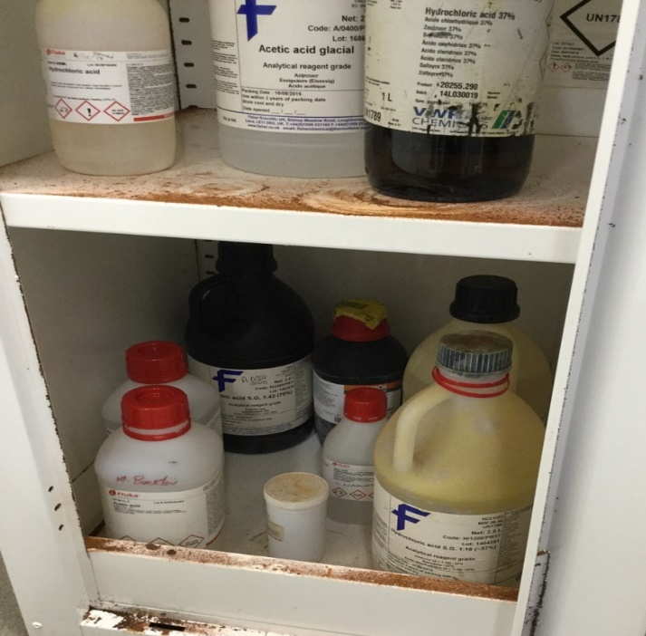
Storage of acids in acid cabinet there are areas for improvement:-

Acetic acid (also flammable) is incorrectly stored in this acid cabinet.

Nitric acid should be separated from other acids in a tray or tub. The nitric acid here has expired and must be disposed of.

There is evidence of rust in the cupboard which indicates corrosive fumes/liquids have leaked and not been investigated/cleaned up.

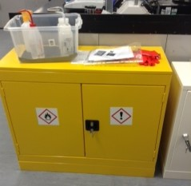
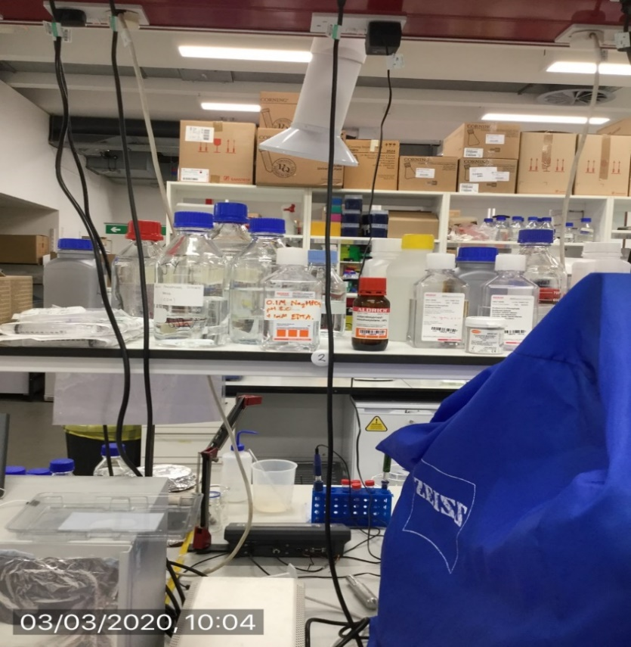
Liquids should be moved to below shoulder height Put wash bottles back in cabinet when finished for the day

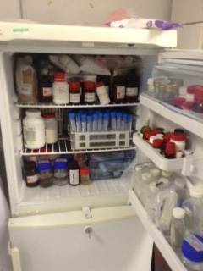
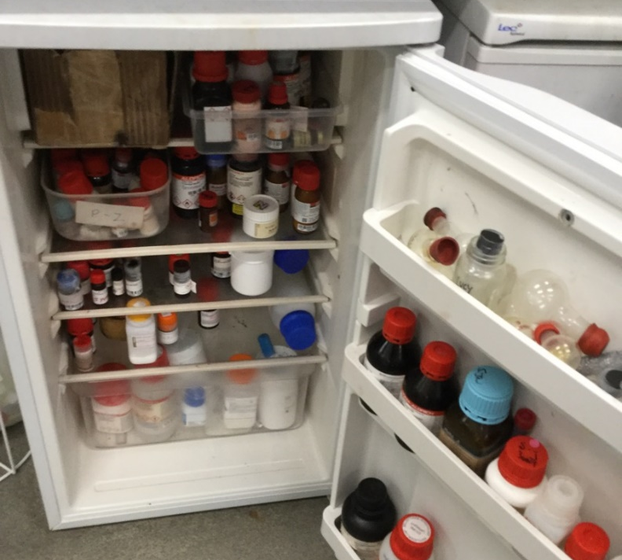

Fridges; more secondary containment would improve segregation

