Verified / Date: | Assessed by: | Approved by: | Building / Location: | Assessment ref no: | Expiry date:
Task/Premises: Working in high-risk areas involves exposure to a wide range of hazard types e.g., chemical, physical, biological, or ergonomic. Common hazards which require procedural, behavioural and/or management controls to be implemented to ensure safe working practices and compliance with legislation detailed here. PIs (Principal Investigator) and others with responsibility for high-risk areas are encouraged to use this as a template to create a working general RA (Risk Assessment) applicable to their area/s. Key: E=essential for all high-risk areas B=bespoke dependent on type and risk factors of work done in the area W=work related and/or statutory requirements
Please add as appropriate once known:
LABORATORY HAZARDS
insert hazard symbol here | insert hazard symbol here | insert hazard symbol here | insert hazard symbol here | insert hazard symbol here | insert hazard symbol here
CONTROL MEASURES
insert hazard symbol here | insert hazard symbol here | insert hazard symbol here | insert hazard symbol here | insert hazard symbol here | insert hazard symbol here

Activity | Hazard | Who might be harmed and how | Existing measures to control risk | Risk rating | Result
Fire prevention and protection  E=essential | Fire  Smoke | Staff and students, visitors.  If present within the building during fire  Death  Burns  Smoke inhalation | - Induction arrangements cover security and fire awareness and include how to locate and use a fire door to exit the building and the location of the fire assembly point(s).  - All new staff complete fire awareness e-training.  - Fire alarm system are in place and tested weekly on day at time to enable users to identify the sound of the alarm  - Wednesday 09:15 – Schuster  - Monday 08:00 – Alan Turing  - Fire evacuation practices are carried out annually  - Induction covers the importance of maintaining clear fire exit routes and keeping the doors closed unless essential. Induction also covers the need for high general housekeeping standards.  - Monthly self-inspections must highlight any fire risks.  - Ready access to fire extinguishers is available for use by trained users.  - Staff ‘hosts’ responsible for safety and, if required, evacuation of visitors.  - Evacuation marshals attend suitable training and assist where possible during evacuations during normal working hours.  - Requests to work out of hours include emergency action in case of fire and use of fire routes and doors.  - The section on chemical storage must also be considered in a DSEAR assessment. | LOW | A
Action in the event of an emergency  E=essential | Not being aware of the evacuation procedure in the event of an emergency.  Injuries/chemical contamination  Lack of assistance out of hours | Staff, students and visitors.  Lack of awareness  /unacceptable behaviours when the fire alarm sounds may result in assuming that real alarms are practice drill and subsequently delay evacuation leading to being trapped by fire or other life threatening incident.  Individuals may not find the first aid kit, emergency showers, fire exits | - Users are instructed and empowered to act if they suspect an emergency situation to activate the fire alarm to trigger evacuation of the building.  - All incidents are reported as required to the person responsible for the area and to a School Safety Advisor  - First aid notices are situated in prominent places around the building to be consulted when first aid is required for appropriate response  - For life-threatening emergencies: Call emergency services on 999, then inform Campus Security.  - For serious injuries and illnesses (and out of hours first aid): Call Campus Security on 0161 306 9966.  - For minor injuries and illnesses 9am-5pm: Locate first aider using QR code located on the First aid notice  - First aid provisions within the area are checked as part of monthly self-checks in high risk areas.  - How to contact Security if required using the telephone number on the back of UoM ID cards (0161 3069966) is emphasised at induction | LOW | A
Accessing high risk areas  E=essential | Individuals enter the area unaware of multiple risks  Individuals enter the area and cause harm to other individuals or equipment  Individuals do not know how to interpret and/or ignore high risk area safety signage | Staff, students, visitors and/or intruders.  May not be aware of hazards and controls due to inadequate or lack of signage  Lack of knowledge /training to understand signage to enable entrants to know what hazards and controls are present in an area  Entrants ignore safety signage e.g. not wearing safety spectacles in designated areas  Safety signage is inaccurate  Individuals may get/be allowed in without access permissions due to doors being ajar and people not challenging their presence or noticing them. | - Access to high-risk areas should be restricted and are only permitted for those who have received full area induction and approved by the area responsible person.  - Doors should be closed unless the door is required to be open when passing through it.  - The entrance to each high risk area will have signage information provided by and to include the responsible person contact, emergency contacts, any significant hazards and control measures there in e.g. PPE that must be worn.  - Safety signage displayed will include pictograms depicting hazard warnings (yellow triangles) and mandatory control measures (blue circles). These must be regularly reviewed by the responsible person and kept up to date.  - “Overnight equipment permit” form should be placed next to each experiment left unattended to highlight main risks at a glance to other lab users.  - Out of hours access for staff and students is limited to those who have been granted key card access to the main entrance, corridor and area access control system. This is only granted after Departmental health and safety induction and/or the area induction have been completed along with a risk assessment that includes out of hours working controls and an access request approved by the supervisor/PI  - Access may be revoked at any time if non-compliance, such as not signing in the log book, or staying beyond time boundaries, or other rules are not followed. | LOW | A
Working in high risk areas  E=essential | Lack of knowledge and experience  Lack of competence and/or training  Inadequate risk assessment of work and/or situations | The individual and others in the vicinity and building  Lack of competence and/or training  Inappropriate action or lack of action could lead to incidents and injuries which supervision and training could have avoided | - Induction, including identified specific equipment and technique training must be provided by the PI/manager or competent delegate and local records kept.  - Training and development to a competent state must be an on-going process managed by the PI/Manager, competence must be recorded.  - Training and competency must follow guidance set out in by the Faculty  - Training needs analysis for any task specific and knowledge related aspects of work need be identified for workers in the area by the PI/Manger as required. This process must be repeated regularly to ensure competence is maintained.  - Workspace users to be made aware of Department Health and Safety Policy, the contents of it and where it is located during workspace inductions | LOW | A
Working in high risk areas  E=essential | Thermal comfort  Extremes of heat and cold effect ability to work/concentrate/manipulate experiments | Staff, students and visitors.  Failure of the system can result in uncomfortable temperatures | - Staff/students must report any failings or concerns to Estates (Helpdesk) by calling 52424 or using the on-line reporting form.  - Staff/students should also report to their manager/PI.  - Fan heaters or air conditioning units are not to be brought into the space unless facilitated by Estates. | LOW | A
Working in high risk areas  E=essential | General Ventilation  Equipment failure  Insufficient ventilation either natural or forced | Staff, students and visitors.  Lethargy  Discomfort  Lack of ventilation decreases the supply of fresh air and could affect temperature and/or odour within the area leading to adverse health effects | - High-risk areas are subject to regular air changes.  - Provision is managed and maintained by the Estates function.  - Faults are reported to the Estates helpdesk by area users.  - If it is suspected that ventilation/make-up air is not functioning correctly, the contact number for estates is x52424 from an internal phone or 0161-2752424 from an outside line /mobile. | LOW | A
Working in high risk areas  E=essential | Inadequate lighting | Staff and students, Visitors.  Eye strain  Trips/falls/slips  Impact injuries  May walk into something or something may fall onto individual as they reach for an item | - Lighting levels are maintained as the building was designed and Estates maintain the infrastructure and change/fix the lighting on request. Report any concerns to Estates (Helpdesk) by calling 52424 or using the on-line reporting form  - Windows are provided for natural lighting.  - Good housekeeping is in place to minimise items that individuals may trip over if lighting is low. | LOW | A
Working in high risk areas  E=essential | Poor housekeeping | Staff and students, Visitors.  Stress from not being able to locate items.  Tripping up on unexpected items.  Cuts/falls/bruises/sprains/strains from slipping on items left on the floor or surfaces.  Items can act as fuel for fire. | - Reasonable standards of housekeeping are regularly maintained, and checks recorded on a monthly basis by users.  - Staff and students agree during induction to read and abide by the Department’s health and safety policy which states the guidelines for housekeeping.  - Refer to activity “fire”. | LOW | A
Working in high-risk areas  E=essential | Lack of space  Safe access and egress | Staff and students, Visitors.  Bruises, sprains and strains - lack of space can lead to injuries through collisions with furniture, equipment or other persons.  Egress is restricted or prohibited by items stored incorrectly. | - Use of appropriate sized furniture.  - Reasonable standards of housekeeping are maintained and checked on a monthly basis by users. Staff and students agree during induction to read and comply with the Department’s health and safety policy which states the guidelines for housekeeping.  - Space is kept between equipment to enable safe entry and exit, minimum 1.5m  - For rooms with single entry/exit point flammable materials are stored as far away from the entry/exit point as possible to maximise the maintenance of safe exit routes in the event of a fire/incident. | LOW | A
Working in high-risk areas  E=essential | Poor Hygiene | Staff and students, Visitors.  Discomfort  Inadequate cleaning, water burn, no towels can lead to dermatitis | - Water temperature at hand wash sink can be adjusted and is limited at source.  - Soap and paper towels are provided and maintained by area staff or users | LOW | A
Working in high-risk areas  E=essential | Water/  Legionella | Staff and students, Visitors.  Legionnaires disease could be contracted from inhalation of water aerosol containing the bacteria from unmanaged/treated water systems | - Any taps, hoses, water transfer systems or other equipment that have been identified as potential sources of Legionella (i.e. those not used on a daily or weekly basis) are flushed on a weekly basis for two minutes to reduce the possibility of a Legionella outbreak. This should be recorded.  - Eye wash stations and emergency showers should be flushed for 2 minutes every week and recorded locally.  - PIs/Manager are responsible for any research or teaching which uses specific water storage facility such as water baths or coolers and for managing the risk of Legionella arising from such facilities.  - PI/Manager to ensure any potential Legionella containing substances (such as coolant in workshop equipment) is tested and replaced as necessary.  - LabCup would be a suitable asset management system to manage this process. | LOW | A
Working in high-risk areas  E=essential | Waste management/ disposal | Staff and students, visitors.  Discomfort from poor housekeeping and odours | - A variety of waste bins/streams are supplied for recycling and disposal needs. These are covered in local Induction.  - House services staff dispose of general waste regularly from corridors and kitchens.  - Hazardous waste including Chemical waste is dealt with by those who generate it following risk assessment. Disposal of waste on a routine basis via the correct waste route as advised by the Technical team, see Department H&S policy.  - Disposal may be in-house or, for hazardous chemicals, using an external contractor.  - Spill kits are provided if required and the area induction process ensures users are aware of how to use and replenish them. Spillages must be cleaned up as soon as is practicable and disposed by consulting the technician team and/or Department Safety Office.  - Chemical hazards are assessed via experimental RAs including waste requirements.  - Waste disposal processes are in place for other waste types, see local rules. | LOW | A
Working in high-risk areas  Sitting or standing  E=essential | Lack of or inappropriate seating  Chemical contact | Staff, students, visitors.  Aches and pains from sitting down (tired legs, injuries/illnesses) and seating is not available.  Contaminated seating may cause injury e.g. dermatitis and burns. | - Suitable seating is provided in all areas as required.  - The seating is and must be wipe-clean (not fabric) in wet chemistry areas and chemical spillage onto seats must be dealt with immediately. Contaminated seats must be removed from use and segregated until cleaned and dry and may need to be disposed of, depending on the chemical.  - Ergonomic hazards are dealt with separately. | LOW | A
Working in high-risk areas  E=essential | Use of mobile phones/devices  Earplugs and earphones | Staff, students, visitors.  Lack of awareness within surroundings leading to vulnerability.  Unable to hear instructions  Unable to hear fire alarms  Distraction from work activities  Chemical contamination of phone/device. | - The use of mobile phones/devices is limited within high-risk areas to use for researching/looking up information in relation to work being carried out or accessing appropriate work-based applications.  - The use of earplugs and earphones is discouraged but allowed/prohibited within this area.  - If allowed all those wearing earplugs and headphones must have the sound level where they can still be aware of the people and activities around them to respond in an emergency.  - Care must be taken to ensure cross contamination does not occur. | LOW | A
Working in high-risk areas  E=essential | Ingestion of substances leading to ill-health | Staff, students, visitors.  Eating and drinking I the work area leading to ross contamination or ingestion of hazardous substances  Contamination of equipment with food and/liquids may lead to malfunction | - Eating and drinking is prohibited in high-risk areas.  - In some spaces e.g. working with chemicals or soldering, this is prohibited.  - Suitable rest facilities away from the work area are provided. | LOW | A
Traversing around the high risk area.  E=essential | Uneven or damaged flooring | Staff, students and visitors.  Chemical burns  Impact injuries  Sprains and Strains  Inappropriate footwear can catch in flooring that changes level or is in dis-repair, causing trips, slips and falls. | - Individuals should wear flat, closed toe, wipe-clean shoes, where there is a risk of cross contamination/spillage.  - Regular checks of the area by users, PIs, managers and Safety Office monitor this.  - Staff/students must report any failings or concerns to Estates (Helpdesk) by calling 52424 or using the on-line reporting form.  - Care should be taken in high risk areas at all times to help prevent injuries or incidents. | LOW | A
Traversing around the high risk area.  E=essential | Obstructions and/or spillages | Staff, students and visitors.  Slips, trips and falls  Bruises  Sprains  Strains  Fractures | - Reasonable standards of housekeeping are maintained and checked on a monthly basis by users. Staff and students agree during induction to read and abide by the Department’s health and safety policy which states the guidelines for housekeeping.  - Trailing cables must be positioned neatly away from walkways or highlighted with hazard tape.  - Faults, repairs and maintenance are reported immediately to Estates (Helpdesk) for repair/replacement  - Floors kept clean, dry and clear of obstructions particularly exit routes. Spillages to be cleared immediately – spill kits are available.  - Cabinet drawers and doors are kept closed when not in use  - Waste bins are supplied for general and recyclable waste reducing the build-up of rubbish in corridors and spaces.  - Marked pathways are followed.  - Adequate lighting is based on identified activities/tasks in the areas as deemed sufficient during building design specification. Emergency lighting will turn on if standard lighting system is faulty to ensure there will always be light in the areas.  - Signage is posted on the doors informing all users of emergency protocols and the telephone number for Security and first aiders if medical help is needed | LOW | A
Use of display screen equipment  Repetitive/prolonged use of equipment or tasks  E=essential | Incorrect posture whilst using DSE  Incorrect workstation set up  Prolonged use without breaks  Electrical hazards | Staff and students.  Musculoskeletal injuries/disabilities  Limb disorders  Eye strain  Headaches  Back pain  Repetitive strain  Fatigue  Electric shock | - Please refer to the DSE policy, guidance and poster for more information on how to set up your workstation properly  - Complete DSE Self-Assessment for a Safety Advisor to review and report back with any recommendations or actions. This is mandatory for everyone using the Department facilities. This is distributed during the induction process.  - Set up workstation to a comfortable position with good lighting and natural light where possible  - Take regular breaks away from the screen, at least some activity or stretching every 20 mins and a 5min break away from the workstation every hour.  - Regularly stretch your arms, back, neck, wrists and hands to avoid repetitive strain injuries. Refer to workstation exercises here  - Provision of adjustable equipment and furniture available following DSE assessment  - Refer to use of electrical equipment.  - Any work of a repetitive nature must be subject to a separate risk assessment in consultation with a Safety Advisor | LOW | A
Manual Handling  Carrying, lifting, pulling, pushing heavy loads e.g. furniture, PCs, stationery, other Lab equipment, rigs and chemicals.  E=essential | Manual Handling  Damage to equipment  Spillage of chemicals | Staff, PG students and visitors.  Back pain bruises, sprains, strains, fractures.  Improper manual handling- incorrect posture/lack of awareness.  Carrying or moving heavy items can cause pain, sprains, strains, fractures and if dropped, fractures / bruises may result. | - Staff are trained via SLD courses (TLCO510 or TLCA500 as appropriate), and familiar with correct handling technique and seek assistance when needed. Maximum load any person may lift is 25 kg at waist height – this may be less depending on the individual and any lift above the shoulder or below the knees.  - Any manual handling that falls outside of the scope of the manual handling training or is particularly complicated must be specifically risk assessed. Please see Faculty manual handling checklist to aid users in considering the risks associated with manual handling  - Some items may need more than one person to handle. Loads are broken down into smaller, more manageable weights and sizes where possible; journeys are planned to minimise the time an object is handled. Additional staff are used to open doors and assure clear passage.  - Lifts used rather than stairs when possible.  - Adequate rest breaks are taken; handling activities are distributed throughout the team; staff with known health conditions are not asked to do tasks that may aggravate an existing condition  - Perform kinetic lifting with feet apart, load held close to body and in front of individual  - Plan route to avoid uneven or poor-quality surfaces  - Identified manual handling equipment is inspected at least annually and records kept locally. LabCup would be a suitable asset management system to manage this process. | LOW
General use of equipment  E=essential | Equipment related hazards | Staff, students and visitors  Entanglement, entrapment and impact/crush injuries | - All equipment use is suitably risk assessed.  - All users have received sufficient training. Training records are kept.  - All users are supervised appropriately until competence is assured and recorded. | LOW | A
Use of electrical equipment  E=essential | Electricity | Staff, students and visitors.  Electric shock by contact with defective parts or live wires  By not following procedures and/or resetting trips without authorisation  Fires, burns, electrocution from powering components connected to the mains power source that may be defective  Can cause fire and/or burns | - In addition to general use of equipment control measures listed above;  - If an electrical circuit trips out and the equipment stops working contact estates (52424), (external line: 0161 275 2424). Only the Estates function must reset tripped circuits. Access to electrical/fuse boxes is prohibited for all other staff. ALWAYS wait for estates to check the circuit before attempting to use the equipment.  - All portable electrical equipment in high-risk areas is tested at least annually on the portable appliance testing (PAT) schedule. Electrical items are labelled with the test expiry date.  - All fixed electrical equipment in high-risk areas is tested at least 5 yearly on the fixed appliance (FAT) schedule.  - All new or recently acquired portable electrical equipment must have a portable appliance test. This includes items brought from home.  - All equipment that has been permanently relocated to be PAT testing before use.  - All mains powered home-built equipment requires PAT testing before use  - For high voltage equipment (above 1000V) see separate section below.  - Use equipment as per manufactures guide.  - Visual inspections of equipment for obvious defects are carried out with any defects reported and use stopped immediately.  - PAT stickers are checked for validity.  - Training covers the need to ensure that electrical equipment is kept dry making sure that wires and cables never make contact with liquids. Extra care is taken when filling water systems not to get electrical components wet.  - Items are switched off and made safe after use. | MED | A
Work at Height  B=bespoke / W=work related | Falls  Falling objects | Staff and students, visitors, external contractors  Users fall from ladders or other height or drop items which can injure others through direct impact or indirectly through damaging equipment | - Users who are required to use steps, ladders or other access equipment must complete the working at height training course available through SLD TLCO500. Others may use access equipment if essential and if they are supervised.  - Following training, users must read sign and follow the specific working on ladders risk assessment.  - Ladder checklists must be performed annually and records should be kept in the local safety file.  - Any work at height that falls outside of the scope of the working at height training must be specifically risk assessed e.g. use of tower scaffold, MEWP.  - Identified working at height equipment is inspected at least annually and records kept locally. LabCup would be a suitable asset management system to manage this process.  - Pre-use visual checks must be done by the user EVERY time especially of any locking mechanisms.  - Different types of working at height equipment e.g. access steps, ladders, foot stools, are available to allow users to choose the most appropriate for the task. Some equipment has extra control measures e.g. some access steps contact with the ground when stood upon. | MED | A
Use of power-driven equipment with mechanical hazards.  B=bespoke / W=work related | Fast-moving mechanical drives  Access to mechanical hazards of the equipment  User wearing loose clothing or long hair | User, visitors  Risk of entanglement, entrapment and impact/crush injuries  Fire  Risk of entanglement | In addition to general use of equipment control measures listed above;  - Standard Operating Procedure (SOP) is followed.  - Where appropriate, a conveniently positioned mushroom shaped emergency stop button or foot bar (safety critical device) is present to quickly stop the machine in an emergency which is functionally tested weekly and recorded.  - Machine is positioned beside barriers to segregate the user from the danger zone.  - Sufficient space is provided around machines to allow safe access and operation.  - Users do not wear any loose clothing that can be caught in the machine and tie long hair back  - Samples are not handled until machine has stopped fully  - Loading of machine and execution of test program is by a single operative so they cannot be near the moving or hot components when the machine is run.  - Machinery turned off when not in use.  - High standards of housekeeping is maintained to ensure swarf isn’t allowed to build up and cause additional risks such as fire.  - Machine is serviced regularly. Power is isolated during servicing, which is only performed by fully trained and competent staff or qualified engineer.  - Machine is segregated by barrier to separate passers-by from the danger zone  - Display warning sign to warn people in the area  - Cut-resistant gloves are used. Regularly check thickness of samples to monitor progress.  - Equipment is switched off and made safe after use.  - Sample holder and push stick is used on the machine to avoid using fingers  - Users must not access the mechanical parts of the machine while it is running. Must wait till it has fully stopped.  - Users must wear appropriate work wear or lab coat, safety glasses BS EN 166 and cut resistant gloves as necessary BS EN 388. | MED | A
Use of equipment  B=bespoke / W=work related | Contact with hot surfaces  Prolonged exposure to high temperatures | User and others in the area  Contact can cause burns and/or fire if combustible materials in vicinity | In addition to general use of equipment control measures listed above;  - Display warning signs in the area to warn of high temperatures and hot equipment.  - Users allow samples/equipment to cool before handling and/or use heat resistant gloves for hand protection (BS EN07).  - If handling hot items cannot be avoided heat resistant gloves and appropriate handling equipment e.g. tongs are used.  - Good working practices in place: tidy workspace, free from combustibles and flammable materials, safe location for tool cooling.  - PPE: lab coat, safety glasses (BS EN 166) and heat resistant gloves for hand protection (BS EN 407) are utilised as appropriate.  - Temperature is monitored for correct and stable temperature with calibrated thermocouple and never left unattended without experiment in progress sign.  - Equipment is switched off after use. | LOW | A
Use of furnaces  B=bespoke / W=work related | Heat | User and those in the vicinity  Risk of burns and fire | In addition to general use of equipment control measures listed above  - If possible, users wait for samples to cool before opening, use a temperature probe to ensure a safe temperature before opening.  - Users wear heat resistant gloves and UV resistant visor if necessary (heat resistant gloves are typically 160 degrees Celsius, no glove can be used on a furnace with high temperatures, the gloves would melt at these temperatures.  - Users check the temperature is set correctly and continuously check if it is stable  - Users do not stand too close when hot and stand to one side when opening the door  - Users insulate the bung if required and contain the sample if risk of contaminating furnace  - Any excess heat and or fumes are directed out of the building as appropriate. | LOW | A
Use of hand tools (like Sharp / pointed tools, Scalpel blade, and so on).  B=bespoke / W=work related | Sharp cutting edges | Users /Others in proximity / Visitors  Risk of cuts and puncture injuries | In addition to general use of equipment control measures listed above;  - Use of ‘open bladed’ tools, e.g. scalpels is avoided if possible or substituted e.g. Scissors.  - Users make safe after each use, e.g. razor blades to be put in sharps bin after use, knives to be replaced into protective cover.  - Items are placed in safe storage immediately after each use. Cutting tools should never be unattended.  - Cutting tools are not placed too close to the edge of a workstation to avoid falling off onto legs and feet  - Use of cut resistant gloves are considered when appropriate.  - Safe cutting techniques are used e.g. cut away from the body and away from the hands and fingers | LOW | A
Use/handling glassware  B=bespoke / W=work related | Broken and damaged glassware  Sharps | Operator and those in the immediate vicinity  By contact with broken glassware on discovery or handling.  Cuts | In addition to general use of equipment control measures listed above;  - Users check that glassware is suitable for procedure before use, make sure it is in good condition, free from chips and cracks.  - Users handle with care and do not apply excessive force.  - Lubrication is used if possible.  - Users wear cut resistant gloves or use correct tools  - Use dust pan and brush or forceps to pick up broken pieces. Do not use hands. Dispose of in designated glass bins.  - Wear cut-resistance protective gloves (EN407) as required for handling broken glass.  - Be trained and supervised until fully competent. Users are inducted prior to Lab work commencing.  - Make sure all components are appropriate and in good condition, free from defects before use and storage.  - Never apply excessive force to joints. Use lubrication where possible. | LOW | A
Use of syringe needles  B=bespoke / W=work related | Needle sticks from disposable syringe needles.  Sharps | Operator and those in the local area by contact with sharp needle whilst in use or accidentally.  Cuts, puncture wounds, grazes.  Depends on substance in syringe. | In addition to general use of equipment control measures listed above;  - Blunt needles to be used whenever possible.  - Use Luer lock needles wherever possible when blunt needles are inappropriate.  - Sharp tipped needles (e.g. hypodermic style needles) require extra precautions.  - Sharp tipped needles. Use PPE: impact resistant eye protection (EN166), cut resistant gloves (EN407) and lab coat.  - Never use excessive force with a syringe and needle.  - Never re-sheath a sharp needle and dispose of directly in to the designated sharps bins located in the work area or store safely after use.  - Never leave a syringe unattended – lab users may accidentally make contact with the sharp needle point.  - For blunt and Luer lock needles use PPE: impact resistant eye protection (EN166) lab gloves and lab coat. If activity with blunt needles involves manually piecing through any material then use cut resistant gloves (EN407), instead of lab gloves. Never use excessive force with a syringe and needle.  - Never point a needle towards your face or body.  - If a needle stick injury occurs purge the puncture wound by squeezing to draw out any contaminants with blood and seek first aid advice. | LOW | A
Use of pressure vessels  B=bespoke / W=work related | Overpressure | Staff, students and Visitors  Impact injuries from blast.  Exposure to chemicals or substances within the vessel  Fire/explosion | In addition to general use of equipment control measures listed above;  - All pressure vessels above 250 bar/L should be captured on the Allianz system and subject to statutory inspection in line with written scheme of examination.  - Pressure vessels outside the scope of statutory inspections are subject to pre use checks that are recorded. These vessels should be placed on LabCup with the expiry of the pressure relief value (PRV) so that all safety critical equipment can be tracked.  - Pressure vessel use must follow the Faculty pressure vessels guidance | MED | A
Use of autoclave  B=bespoke / W=work related | Heat and pressure | User and those in the vicinity  Risk of burns and explosion | In addition to general use of equipment control measures and use of pressure vessels listed above;  - Interlock on autoclave prevents access to the inside at temperatures above 50oC.  - Autoclave is serviced and insurance inspected every 12 months. LabCup would be a suitable asset management system to manage this process.  - Autoclave only operated by trained and competent users with records.  - Users record each cycle they run in the local log book where appropriate.  - Users allow to cool before opening and hot items handled with heat-resistant gloves.  - Users stand back when opening the autoclave avoid hot steam coming in contact with face.  - If pressure is not maintained at the correct level users switch off at the mains and report the fault. | LOW | A
Use of equipment  B=bespoke / W=work related | Stirrers | User and others in the area  Can cause liquid spillage  Entanglement in mechanical stirrers. | In addition to general use of equipment control measures listed above;  - Size of container is sufficient to accommodate the movement of the liquid.  - Speed is set to the lowest required and continuously checked is correct and stable. Equipment is turned off after use  - Mop up and decontaminate if spillage occurs (Refer to chemical risk assessment for chemical hazards).  - Ensure no loose clothing and hair tied back when using mechanical stirrers. | LOW | A
Use of equipment  B=bespoke / W=work related | Balance | User and others in the area  Spillage of chemicals causing contamination | In addition to general use of equipment control measures listed above;  - Balance and tools used for weighing are always cleaned after use.  - If weighing out hazardous chemicals, balance is moved into the fume cupboard first before opening up the chemical. (Refer to chemical risk assessment for chemical hazards).  - Fume cupboard is checked for correct operation as per department procedure and recorded.  - After weighing, seal the container are sealed and all items are decontaminated before moving out of the fume cupboard.  - Balance is calibrated regularly to ensure accuracy. | LOW | A
General use and storage of chemicals  B=bespoke / W=work related | Common hazards associated with the storage, use and disposal of chemicals. | Staff, students, users, visitors and those in the area.  General risk of health damage  Chemical injuries inc. exposure by contact, inhalation.  Damage to equipment  Exposure to chemicals if not properly contained.  Contamination of work surfaces/equipment  Contact/slips, trips and falls with liquid spillages | - The safety team MUST be contacted for advice BEFORE hazardous/toxic chemicals are purchased, stored or used to enable control measures such as additional first aid or gas detection to be considered and implemented e.g. use of phenol, hydrogen fluoride, toxic gases, mercury (this list is not exhaustive).  - All specific experimental use and handling of chemicals will be suitably risk assessed to include any compliance requirements as necessary.  - All use and handling of chemicals must be by a trained and competent person or closely supervised.  - Door signage states identified hazards.  - All chemicals must be segregated (using information form the safety data sheet as part of chemical RAs) from others dependent on compatibilities and stored within a suitably labelled cabinet/fridge when not in use.  - All chemicals must be suitably labelled.  - Each area will maintain a chemical inventory (LabCup) which is regularly reviewed and unwanted items disposed of as required.  - Storage will generally comprise cabinets to segregate;  - Flammables from non-flammables.  - Halogenated solvent from non-halogenated solvent.  - Organic acids from inorganic acids.  - Aqueous water-based from organic-based  - Alkalis from acids.  - Oxidising agents from most other types of chemical.  - Gases from liquids.  - Very hazardous from everything else e.g. mercury, hydrogen fluoride.  - Pyrophoric reagents.  - Most, but not all, must have a specific cupboard of suitable construction e.g. flammable storage, acids, alkalis, very toxic, otherwise secondary containment and distance can be used.  - Monthly users' self-checks are conducted to assess if storage cabinets/packaging/expiry dates remain suitable and in good condition and stored appropriately within guidelines.  - Storage facilities are checked on a regular basis for damage and/or corrosion and replaced as necessary.  - Waste disposal routes for all substances are available and must be followed. See separate document on waste disposal routes.  - The storage of waste chemicals awaiting final disposal must also be considered and Departmental waste disposal procedures followed.  - Users wear correct PPE (lab coat, correct chemical specific gloves, safety glasses) and ensure all are free from defects and adequately stored between uses.  - Eye protection is mandatory in Laboratory spaces unless explicitly exempt with justification recorded here.  - If chemical has a workplace exposure limit, or other hazardous properties that require it, always perform activity in a fume cupboard or other local exhaust ventilation. Ensure that the LEV has a valid inspection date, with the airflow (and sash height if applicable) at the correct level, that the monthly check has been performed and that the hood is free of incompatible substances.  - Users perform correct glove removal to ensure the outer part of the glove isn’t touched.  - First aid provisions are available within the space and checked for completeness / in date as part of self-inspection regime.  - Department spills procedures are available and followed, briefly;  - Each spill must be risk assessed to ensure users are not at risk due to over exposure/contact. In some cases this may mean that the area needs to be evacuated depending on the size and hazardous nature of the spilled substance. Refer to local rules/procedures for spills.  - Spill kits are available.  - Spilled substance is collected safely into suitable container for chemical waste disposal.  - The use of chemicals require registration with occupational health by emailing the lab screen questionnaire to occupational health.  - The Department operates a non-compliance policy to encourage wearing and appropriate use of PPE. Sanctions are in place for non-compliance.  - Department Policy refers to chemical safety and is cross- checked for compliance.  - Advice must be sought from School Safety Advisors if planning to use HF, phenol, pyrophoric materials, toxic gases as special additional control and first aid measures must be in place before ordering these chemicals. If these chemicals are discovered in the area e.g. legacy chemicals report to PI/safety office immediately. | LOW | A
Storage of flammables or explosives within high-risk areas  B=bespoke / W=work related | Fire arising from ignition of flammable chemicals.  Damage to equipment | Staff, students and visitors.  Users in the immediate vicinity and all occupants of the building should the fire spread  Contamination of work surfaces/equipment  Evaporation of spillage | In addition to general use and storage of chemicals control measures listed above;  - Complete DSEAR assessment for the room: Initial screening to identify amounts and then calculated to decide if a spill of all the solvent will reach the lower explosive limit.  - If not, no further action would be required. If there is a potential to reach lower explosive limit then complete full DSEAR risk assessment to allow any hazard area to have a zone classification to decide if gas detection is needed and whether electrical and other equipment needs special protective features in order to prevent it causing a fire or explosion  - Containers containing over 500 ml extremely flammable and highly flammable substances are stored in suitable fire-resistant storage containers  - No more than 50 L of Extremely-flammable/highly-flammable solvent is allowed to be held at any given time within an area.  - No more than 250 L of any type of flammable solvent is allowed to be held at any given time within an area  - All storage areas are bunded with sufficient capacity in the bund to take 110% of the volume of the largest container or 25% of the total volume of liquid stored, whichever is the greater  - Complete DSEAR assessment for the experimental risk assessments: consider the amounts of substances in the area, or due to a work process or chemical reaction, including by-products and/or combustion, and whether there likely to be a release of vapour/gas/dust/decomposition products that could produce an explosive atmosphere. If the conclusion is Yes, a DSEAR assessment must be completed and actions resulting from such implemented.  - School Safety Advisor can advise on where and how much flammable solvent can be stored in a specific area.  - The storage of waste chemicals awaiting final disposal must also be considered and Departmental waste disposal procedures followed.  - Good workplace ventilation is maintained.  - Any cabinet containing flammable materials must be located centrally in the lab to maintain safe egress to fire exits should an incident arise.  - Areas with only one point of access and egress assess the location of chemical storage and additional control measures required.  - Where flammable liquids or gases are handled in laboratories, it is always necessary to control sources of ignition, even if there are no formally designated hazardous areas.  - On open benches use on a bunded tray and use in Fume cupboard or wet benches where possible  - Keep lids on when not in use  - Return to chemical cupboard when not in use  - Avoid using with temperatures above flash point  - Do not store solvent bottles on floor without bunding to control potential spills  - Avoid using flammables near to any ignition source (including electrical equipment) and heat sources | MED | A
Storage/Use of substances with workplace exposure limit values or are suspected as highly hazardous to health.  B=bespoke / W=work related | Exposure to chemicals with hazards classified as carcinogenic, mutagenic or reproductive toxins (CMR), sensitisers, toxic or nanomaterials | User and others in the area  Exposure may lead to cancer, death, birth defects and allergies | In addition to general use and storage of chemicals control measures listed above;  - If chemical has a workplace exposure limit, or other hazardous properties that require it, always perform activity in a fume cupboard. Ensure that fume cupboard has a valid inspection date, with the airflow and sash height at the correct level, that the monthly check has been performed and that the hood is free of incompatible substances.  - Sash should be closed when not in use, kept as low as possible when working in it and not above the maximum safe height indicator.  - Scales/balance are moved to the fume cupboard if weighing out  - Bottles/samples are labelled clearly and sealed when not in use  - Work area is decontaminated regularly  - Good workplace ventilation is used.  - Hand washing before leaving the lab is encouraged.  - The use CMRs, sensitisers and nanomaterials by staff and PGR students require registration with occupational health by emailing the lab screen questionnaire to millocchealth@manchester.ac.uk (ask the Safety Advisor for a copy).  - PI ensures that Occupational health fitness to work records are up to date. | MED | A
Use of corrosive chemicals  B=bespoke / W=work related | Contact with corrosive chemicals | User and those in the laboratory  Contact or exposure through loss of containment will cause damage to living tissue | In addition to general use and storage of chemicals control measures listed above;  - Laboratory has a Diphoterine spray, (or sterile eye wash) for use.  - Can be used for all liquid and solid corrosives including acids, bases, oxidisers and reducing agents WITH THE EXCLUSION OF HYDROGEN FLUORIDE BURNS  - If exposed, users know that they should use the entire bottle where the corrosive has made contact  - Users consider any fumes or heat generated when mixing chemicals together and how this is controlled e.g. in fume cupboard, with cooling. This should be documented in a chemical risk assessment. | MED | A
Use of chemicals with hazard statements “fatal if inhaled/swallowed/contact with skin”  B=bespoke / W=work related | Acute toxicity chemicals | User and others in the laboratory  Risk of fatality upon exposure | In addition to general use and storage of chemicals control measures listed above;  - Newly arrived boxes are opened in fume cupboard in case spilled during transport  - Stored in a locked poison cabinet within secondary containment for transport to fume cupboard  - All containers remain sealed until they are inside the fume cupboard. They are sealed and cleaned again before being brought out.  - Other users are notified of the work before use  - Fume cupboard is not shared during the experiment and decontaminated after use  - Fume cupboard should be left to run for at least a further 15-20mins following decontamination, before next use. | MED | A
Use of Local exhaust ventilation (LEV)  E.g. in fume cupboards, extractions hoses...  B=bespoke / W=work related | LEV failure or inadequate flow leading to exposure to hazardous substances | Staff, Students and Visitors  Contamination or exposure to airborne substances in the area or external to the building (e.g. the roof) where the LEV vents to due to failure of the LEV, lack of knowledge, failure or lack of alarms, inadequate pre-use/monthly checks | - All users must be trained/instructed to use fume cupboards or other extraction equipment that relies on functioning LEV to minimise exposure as identified as part of the induction process. Users must also be instructed on how to ensure LEV is operating effectively, how to carry out pre-use checks and how to report issues.  - All LEV should be captured on the Allianz system and subject to statutory inspection in line with written scheme of examination. This is at least every 14 months.  - LEV must be checked prior to use as per check sheet with records kept.  - LEV must have a monthly self-inspection that highlights any issues if a pre use check has not been completed within that month.  - LEV must have a velocity check monthly with records kept.  - Any faults identified are reported to the Estates helpdesk and Department Safety Office as soon as possible and the LEV put out of service until repair.  - Recirculating LEVs require annual service and records recorded on LabCup.  - Estates contact the department to discuss potential work that may impact on LEV. | LOW | A
Siting and movement of pressurised gas cylinders  B=bespoke / W=work related | Gas at high pressure  Manual handling issues  Pressurised gas cylinders are very heavy and unstable objects | Staff, students and visitors.  By explosion or implosion or leaks in an enclosed space  Improper manual handling- incorrect posture/lack of awareness. Carrying heavy items can cause pain, sprains, strains, fractures and if dropped, fractures / bruises may result.  Asphyxiation | - Those siting and moving cylinders MUST be suitably trained and competent by attending University Compressed gas Safety Workshop (TLCA105) before they can move cylinders or connect up regulators.  - All staff when moving and handling the cylinders must wear designated PPE: lab coat, safety footwear, EN166 safety spectacles and gripper gloves.  - Goods lift is used to transport gas cylinders. People MUST not enter a lift when a gas cylinder is being transported. Key used so lift is locked out and cannot be intercepted to ensure that goods are transported unaccompanied. Cylinder should then be met at designated floor by other means.  - Use churning motion to manoeuvre individual cylinders when moving <5m, and designated gas cylinder trolley to transport them any further distances.  - Only trolleys specifically designed for gas cylinder transport are to be used. Trolleys must be fitted with retaining chain to secure gas cylinder and rear castor wheel so that cylinder may be safely tilted during transport.  - Check cylinder trolley is in good condition, free from defects before each use.  - Check cylinder is firmly secured on the trolley before moving  - Gas cylinder to be secured to lab bench, wall or with metal brackets at all times. Check the stability of the gas cylinder before use. If having difficulty moving gas cylinder, seek assistance.  - Check that the correct, in date and LabCup barcoded regulator is attached during change over. Obtain advice from the technical team if the regulator is not in date and barcoded before attaching it to the cylinder. | MED | A
Use of cylinders  B=bespoke / W=work related | Physical damage caused by exposure to the full force of the escaping gas.  Cylinder explosion or implosion  Gas under pressure | Users and those in the vicinity  Risk of physical injury to those handling them  Staff, students and visitors.  By explosion or implosion or leaks in an enclosed space  Asphyxiation | - All specific experimental use and handling of cylinders will be suitably risk assessed to include any compliance requirements as necessary.  - All use and handling of cylinders must be by a trained and competent person or closely supervised.  - Door signage states identified hazards.  - All cylinders must be segregated (using information form the safety data sheet as part of chemical RAs) from others dependent on compatibilities.  - Each area will maintain a chemical inventory (LabCup) which is regularly reviewed and unwanted items disposed of as required.  - There must be no ignition source (e.g. welding) or other localised high temperature sources in the labs/area when experiments with flammable gases or liquids are done.  - Only used in well-ventilated areas.  - Regulators are managed by the Department, LabCup barcoded and checked regularly by the technical team.  - When fitting regulators PTFE tape may be used to stop leaks following gas suppliers’ advice. Only OIL FREE tape can be used with Oxygen cylinders.  - Gas cylinders are visually inspected and checked for any defects before use.  - Users ensure the associated pipework is suitable for the gas and the pressure of the cylinder. All connections are checked for security/leaks.  - Users check regulator is correct and in date prior to operation and report any defects.  - Cylinder valve is opened slowly and gradually to avoid a sudden change in pressure and continuously monitored to make sure pressure is stable and correct.  - If transporting cylinder from outside the building, allow to acclimatise to room temperature before use, otherwise the sudden change in temperature can damage the cylinder.  - Use is stopped immediately or on discovery if fault occurs and reported.  - In the event of a gas release the response must be risk assessed to ensure users are not at risk due to over exposure/contact. In some cases this may mean that the area needs to be evacuated (especially if alarms activate) depending on the size and hazardous nature of the gas until plans are put in place of the gas has dissipated.  - Equipment is switched off and made safe after use | MED | A
Use of inert gases  B=bespoke / W=work related | Release of inert gases | Users and those in the vicinity  Gas can cause asphyxiation and death by displacing the oxygen in the room | In addition to siting and movement of pressurised gas cylinders and use of gas cylinders control measures listed above;  - Only use in well-ventilated area and/or rooms fitted with oxygen depletion sensors/alarms if there is potential for oxygen percentage within the room to fall below 19%  INSERT GAS CALCULATION  X alarms are installed in the lab/area and tested as appropriate.  - Fixed gas detection systems should be logged on LabCup and service/calibration recorded.  - Portable gas detection meters should be logged on LabCup, calibration recorded if applicable, and user checked logged locally.  Emergency procedures are available as per gas release procedure, briefly;  - If the leak is small, attempt to close off the cylinder valve and contact technical staff, but do not endanger yourself. If time allows eliminate nearby sources of ignition, ventilate and evacuate the laboratory.  - If someone is unconscious or unable to move in an enclosed area and there is a suspected gas leak or spillage, do not enter and do not open the door to ventilate the room. Call Campus Security on 69966. Never attempt to rescue the person  - In the event of a large spill, break the fire alarm break glass call point to initiate a building evacuation. Call Campus Security on 0161-3069966  - All gas leaks are reported to Supervisor and Safety Advisor. Do not re-enter until confirmed safe by safety advisor or technical operations manager.  - Signage warning users not to enter the area when an alarm is sounding is posted. An emergency pack containing hazard warning tape and extra signage is available to use in the event that an alarm is activated. | MED | A
Use of flammable gases  B=bespoke / W=work related | Release of flammable gases | Users and those in the vicinity  Risk of fire and explosion | In addition to siting and movement of pressurised gas cylinders and use of gas cylinders control measures listed above;  - Only work that has been risk assessed, authorised by the PI/Manager, and verified by the Safety Office can use equipment that requires flammable gas. Users are given awareness training with regards to the dangers of flammable gas, detection and alarms and what to do in an emergency situation.  - Only used in well-ventilated area or rooms fitted with flammable gas sensors where calculations show the lower explosive limit can be reached.  INSERT GAS CALCULATION  X alarms are installed in the lab/area and tested as appropriate.  - Fixed gas detection systems should be logged on LabCup and service/calibration recorded.  - Portable gas detection meters should be logged on LabCup, calibration recorded if applicable, and user checked logged locally.  - Flammable gas cylinders are changed, maintained and leak tested by competent staff only.  - Monthly user self-inspections should include checks that alarm monitoring is being carried out and should highlight any issues with alarm testing not being effective.  - DSEAR assessment is carried out where lower explosive limit can be reached.  - The use of flashback arrestors is considered in each case.  - Where vapours or gases may escape into an enclosed space like an oven, or refrigerator, the consequence of an ignition is more likely to be an explosion than a fire. Use spark free electrical equipment  - Classification of zone 2 for 1-2m around valve and outlet (and possibly areas where gas could collect in the event of leakage). Rearrange experimental set up to avoid electrical equipment within this zone if possible.  Emergency procedures followed;  - If the leak is small, attempt to close off the cylinder valve and contact technical staff, but do not endanger yourself. Eliminate nearby sources of ignition, ventilate and evacuate the laboratory  - In the event of a large spill and where safe to do so, break the fire alarm break glass call point to initiate a building evacuation. Call Campus Security on 0161-3069966  - All gas leaks reported to Supervisor and Safety Advisor. Do not re-enter until told safe by safety advisor or technical operations manager.  - Signage warning users not to enter the area when an alarm is sounding is posted. An emergency pack containing hazard warning tape and extra signage is available to use in the event that an alarm is activated. | MED | A
Use of oxidising gases e.g. oxygen  B=bespoke / W=work related | Oxygen enrichment | Users and those in the vicinity  Risk of fire and explosion | In addition to siting and movement of pressurised gas cylinders and use of gas cylinders control measures listed above;  - Oxygen is an oxidiser and may cause or intensify fire  - Only use in well-ventilated area or rooms fitted with oxygen enrichment detection if there is an ability for oxygen percentage within the room to reach 23.5% oxygen  INSERT GAS CALCULATION  X alarms are installed in the lab/area and tested as appropriate.  - Fixed gas detection systems should be logged on LabCup and service/calibration recorded.  - Portable gas detection meters should be logged on LabCup, calibration recorded if applicable, and user checked logged locally.  - Avoid using oxygen near to any ignition source (including electrical equipment), flammables and heat sources  - Only use regulators designed for the specific gas you are using  - PTFE tape must not be used on regulators or fittings for oxygen systems. Unsintered tape (similar in appearance to PTFE tape) is pre-installed by manufacturers on oxygen regulators, but is not widely available and so is not possible to be replace it in labs. PTFE is not to be used as a substitute.  - Dirt, oil, grease or any other contamination can cause a fire and explosion if left on the bullnose or threads of oxygen regulator and fittings. All components should be inspected for cleanliness before installing.  Emergency procedures followed;  - If the leak is small, attempt to close off the cylinder valve and contact technical staff, but do not endanger yourself. Eliminate nearby sources of ignition, ventilate and evacuate the laboratory  - In the event of a large spill and where safe to do so, break the fire alarm break glass call point to initiate a building evacuation. Call Campus Security on 0161-3069966  - All gas leaks reported to Supervisor and Safety Advisor. Do not re-enter until told safe by safety advisor or technical operations manager.  - Signage warning users not to enter the area when an alarm is sounding is posted. An emergency pack containing hazard warning tape and extra signage is available to use in the event that an alarm is activated. | MED | A
Use of toxic gases  B=bespoke / W=work related | Release of toxic gases | Users and those in the vicinity  Exposure cause toxic effects and/or death | In addition to siting and movement of pressurised gas cylinders and use of gas cylinders control measures listed above;  - Only work that has been risk assessed, authorised by the PI/Manager, and verified by the Safety Office can use equipment that requires toxic gas. Users are given awareness training with regards to the dangers of toxic gas, detection and alarms and what to do in an emergency situation.  - Only used in well-ventilated area and/or rooms fitted with toxic gas sensors/alarms were calculated as necessary.  - Toxic gas cylinders are changed, maintained and leak tested by competent staff only.  - Monthly self-inspections should include checks that alarm monitoring is being carried out and should highlight any issues with alarm testing not being effective.  INSERT GAS CALCULATION  X alarms are installed in the lab/area and tested as appropriate.  - Fixed gas detection systems should be logged on LabCup and service/calibration recorded.  - Portable gas detection meters should be logged on LabCup, calibration recorded if applicable, and user checked logged locally.  Emergency procedures followed;  - If the leak is small, attempt to close off the cylinder valve and contact technical staff, but do not endanger yourself. If time allows, eliminate nearby sources of ignition, ventilate and evacuate the laboratory  - If someone is unconscious or unable to move in an enclosed area and there is a gas spill, do not enter and do not open the door to ventilate the room. Call Campus Security on 69966. Never attempt to rescue the person  - In the event of a leak, break the fire alarm break glass call point to initiate a building evacuation. Call Campus Security on 0161-3069966  - All gas leaks reported to Supervisor and Safety Advisor. Do not re-enter until told safe by safety advisor or technical operations manager.  - Signage warning users not to enter the area when an alarm is sounding is posted. An emergency pack containing hazard warning tape and extra signage is available to use in the event that an alarm is activated. | MED | A
Use of gas line  B=bespoke / W=work related | Explosion from rapid release of pressurised gas | Users and those in the vicinity  Cuts injuries caused by flying glass  Risk of asphyxiation | - User is trained and supervised until fully competent.  - Care taken when operating equipment. Gas valve is opened slowly and pressure checked continuously.  - Monitor the gas line for a suitable period to ensure it is stable and at the correct level.  - Turned off after use  - Tubing and connectors checked for good condition and free from defects before use. If fault occurs use is stopped immediately, taken out of use and reported.  - Fume hood sash is lowered as far as possible whilst working and fully closed after use.  - Full PPE (lab coat, safety glasses BS EN 166 and nitrile gloves BS EN 374) is worn.  - The oxygen level in the lab is monitored by sensors. The nitrogen gas line shuts down automatically if the oxygen reduces to dangerous level. If gas alarm sounds, a technician is immediately informed to check the gas alarm panel.  - Maintenance is carried out annually by qualified engineers  - Equipment is switched off after each use.  Emergency procedures followed;  - If there is a leak evacuate immediately. Close the lab doors, break glass to sound the fire alarm and call Campus Security on 0161 306 9966  - Never attempt to rescue an unconscious person yourself in the event of a gas leak  - All gas leaks reported to Supervisor and Safety Advisor. Do not re-enter until told safe by safety advisor or technical operations manager.  - Signage warning users not to enter the area when an alarm is sounding is posted. An emergency pack containing hazard warning tape and extra signage is available to use in the event that an alarm is activated. | LOW | A
Storage of cryogenic liquids  B=bespoke / W=work related | Cryogenic liquid has a liquid to gas ratio of 1:683 at room temp.  Nitrogen gas under pressure,  Nitrogen rich atmosphere | User and those in the vicinity  Risk of asphyxiation from oxygen depletion | - All areas for storage, dispensing or use are risk assessed, well-ventilated with stable, even flooring.  - The PI/Area manager is responsible for calculating the maximum allowable amount of cryogenic liquid and/or pressurised Nitrogen gas which may be taken into/stored in a Lab/high-risk area.  INSERT GAS CALCULATION  X alarms are installed in the lab/area and tested as appropriate.  - Technical staff or the Safety Office may advise on request if the calculation raises any concerns.  - Oxygen deficiency monitoring system is fitted in enclosed areas (e.g. labs) if the amount of cryogenic liquid used in a room could drop the oxygen levels to below 18.5% in a worst case scenario (lack of ventilation etc.). The Safety Services guidance is referred to determine number and type required.  - Volumes stored/used is kept to a minimum to reduce the risk of a nitrogen rich atmosphere.  - Equipment must carry a valid servicing date and must be checked before use to ensure all components are in good condition and free from defects  - Use of shallow, wide-neck vessels are avoided to prevent excessive evaporation  - Dewars are not overfilled.  - In enclosed area, lone dispensing is not allowed. Buddy system is used. NEVER dispense out of hours  - Oxygen depletion monitors alarm at or below 19% oxygen. If the alarm sounds immediately evacuate the area.  - In the event of a large spill, break the fire alarm break glass call point to initiate a building evacuation. Call Emergency Services.  - If someone is unconscious or unable to move in an enclosed area and there is a cryogenic liquid spill, DO NOT ENTER and DO NOT OPEN the door to ventilate the room. Call Emergency Services IMMEDIATELY. Never attempt to rescue the person  - All leaks/alarms reported to Supervisor and Safety Advisor. Do not re-enter until told safe by safety advisor or technical operations manager.  - Signage warning users not to enter the area when an alarm is sounding is posted. An emergency pack containing hazard warning tape and extra signage is available to use in the event that an alarm is activated. | MED | A
Transportation of cryogenic liquids  B=bespoke / W=work related | Cryogenic liquid  (expands around 700-fold when it vaporises at room temperature) | User and those in the vicinity  Risk of asphyxiation from oxygen depletion | - All transportation of cryogenic liquid must be specifically risk assessed.  - TLCA100 cryogenic gases e-training is completed by anyone using any equipment that uses cryogenic liquid and they are supervised until assessed as competent. e.g. Technician should deliver cryogenic liquid in a suitable Dewar for experimental use.  - Users are made aware of the hazards and first aid measures with regards to cryogenic liquid.  - NEVER accompany a Dewar in the lift. The lift must be ‘locked off’ and the Dewar sent to the designated floor by itself. User then travel in another lift or use the staircase to collect the Dewar.  - User visually inspects the unit before use to make sure it is in good condition and free from defects. Any faults or damage are reported immediately and the unit must not be used.  - PPE (fastened lab coat, cryogenic-resistant gloves, face visor and closed-toe shoes) are worn at all times  - Trousers worn to avoid cryogenic liquid splashing onto bare legs. | MED | A
 | Manual handling of Dewar | User  Risk of musculoskeletal injuries | - All transportation of cryogenic liquid is specifically risk assessed.  - TLCA100 cryogenic gases e-training is completed by anyone using any equipment that uses cryogenic liquid and they are supervised until assessed as competent.  - Recommend completing Manual Handling training course  - Use a Dewar trolley to transport Dewars. For large dispensing units already fitted with wheels, use a buddy system and recommend use of safety shoes for grip and foot protection | LOW | A
Use of cryogenic liquid  B=bespoke / W=work related | Cryogenic liquid has a temperature of -196 °C - extreme cold hazard | User and those in the vicinity  Risk of severe cold burns can result from skin contact with the liquid or objects cooled by the liquid or vapour cold burns | - All use of cryogenic liquid is specifically risk assessed.  - TLCA100cryogenic gases e-training is completed by anyone using any equipment that uses cryogenic liquid and they are supervised until assessed as competent e.g. Technician should deliver cryogenic liquid in a suitable Dewar for experimental use.  - PPE (fastened lab coat, cryogenic-resistant gloves, face visor and closed-toe shoes) are worn at all times  - Trousers are worn to avoid cryogenic liquid splashing onto bare legs.  - Dewar NEVER left unattended while dispensing. It must be supervised at all times.  - Only containers designed for use with cryogenic liquids are used.  - Metal jewellery is removed from hands and wrists before handling cryogenic liquid to avoid severe cryogenic burns.  - Dewars are inspected before use for signs of damage that can affect the integrity of the inner flask or its handling.  - Dispensing carried out slowly under low pressure to avoid splash-back  - All pressure systems, piping, isothermal vapour units and Dewars are annually serviced, regularly inspected with records kept.  - Users are made aware of the hazards and first aid measures with regards to cryogenic liquid. | LOW | A
Electronics test and measurement  B=bespoke / W=work related | Electrical | Users /Others in proximity / Visitors  Electric shock | - All users of the equipment must have be trained by a competent person familiar with the relevant safe practices  - Specific risk assessment required for:  - >50 volts AC / >60 volts DC  - intentional connection to human tissue  - low impedance situation, e.g. wet conditions  - High risk experiments (high current, high voltage, rotating machines, energy storage etc.) should be checked by another competent person before first powering up. | LOW | A
 | Heat | User / Others in proximity / Visitors  Minor burns, fire | - User is trained and supervised until fully competent  - Keep area tidy and free from combustible or flammable materials  - Exercise caution on first power-up. Limit supply current to just above expected level.  - Specific risk assessment required for circuits containing intentional heating elements and/or operating at >70oC  - Consider finger guards/covers when components/elements are expected to operate at above 48oC  - Dump resistors might not be considered as a heating element but can quite easily reach >100degC in a matter of minutes and therefore pose a significant risk if not caged.  - Consider signage to warn others of heat hazard | LOW | A
 | Component ejection | User / Others in proximity / Visitors  Minor burns, eye injury | - User is trained and supervised until fully competent  - Wear safety glasses (EN 166:2001)  - Exercise caution on first power-up. Check for reverse connection of electrolytic capacitors before energising the circuit.  - Limit supply current to just above the expected level  - Avoid close visual inspection of an unproven circuit during the first few minutes of operation | LOW | A
Manual soldering  Creation of joints between wires or components using molten solder. The application requires the use of a hot (~370-420oC iron) usually mains powered.  B=bespoke / W=work related | Heat | User / Visitors / Occupants of neighbouring areas  Minor burns to skin, fire | - User is trained and supervised until fully competent  - No soldering equipment should be left unattended while switched on and for a minute after switching off to allow to cool.  - Anyone approaching soldering equipment should assume it is hot.  - 0.11 mm nitrile gloves can be worn to protect hands from spitting solder  - Solder away from combustible and flammable material  - When not in use, soldering irons must be stored in the stands provided.  - Cold water or burn gel should be applied immediately to all soldering iron burns and first aider called to assist. | LOW | A
 | Colophony or rosin based solders | All users in lab  Risk of asthma from Rosin exposure | - The use of rosin-based solders and fluxes should be limited and require registration with occupational health by emailing the lab screen questionnaire to millocchealth@manchester.ac.uk (ask the Safety Advisor for a copy)  - The use of local fume extraction is required when using rosin-based fluxes; or when using alternative fluxes for more than a few minutes a day, according to HSE guidance  - If using extraction, do not begin task unless you have confirmed that the equipment is working. Ensure Allianz inspection is up to date.  - No need for LEV extraction if using lead and rosin free solder and less than a few mins a day when testing requires soldering of testing leads, ensure good natural ventilation  - Label substances clearly and decontaminate work area regularly  - Wash hand before leaving the lab  - Keep away from food and drink areas  - Add to LabCup | MED | A
 | Solder pastes and fluxes | All users in lab  Risk of allergic contact dermatitis | - The use of solders and fluxes that cause allergic contact dermatitis should be limited and require registration with occupational health by emailing the lab screen questionnaire to millocchealth@manchester.ac.uk (ask the Safety Advisor for a copy)  - 0.11mm nitrile gloves should be worn to protect skin from contact  - Label bottles clearly and decontaminate work area regularly  - Wash hand before leaving the lab  - Keep away from food and drink areas  - Add to LabCup | MED | A
 | Lead based solder | All users in lab  Lead poisoning, increased risk for pregnant / breastfeeding mothers. | - Lead at work guidance states below 500oC the lead fume is controlled, soldering irons do not reach this temperature (max 420oC)  - Keep away from food and drink areas  - Wash hands after use  - Add to LabCup | MED | A
Solvent-based cleaning  B=bespoke / W=work related | Chemicals | Users /Others in proximity / Visitors - electric shock  Health damage and fire risk | In addition to general use and storage of chemicals control measures listed above;  - Users wear correct PPE (lab coat, correct gloves, safety glasses) and ensure all are free from defects  - Good workplace ventilation is maintained.  - Solvents are returned to flammable storage after use and not left on sinks/benches.  - The minimum quantity necessary is used and containers are sealed when not in use and stored safely. | LOW | A
Use of above mains power equipment  B=bespoke / W=work related | Use of electrical equipment:240/415VAC  (Specify voltage level if above this)  DC voltage (Specify voltage level) | Staff, students and visitors  Risk of electric shock, fire, burns | - Users are trained and supervised until competent in using equipment. This requires the safe power on and power off all the devices and components included in the test rig.  - All cables and connections are suitably rated, covered/insulated.  - The rating of the cables should be adequate depending on the insulation voltage rating and current rating in the test rig. (Specify here your ratings)  - All live terminals are covered and terminated in isolated blocks.  - Power Supply controls (ON, OFF and emergency buttons for 3 phase and DC) are in a cabinet in the laboratory.  - MCCBs and RCDs inside the cabinet provide over-current protection. These are rated to the specific test rig (Specify here the rating in your test rig and the RCD rating)  - Visual inspection of the equipment before use. A second competent person should also check the equipment before first power up after long period with no use.  - Cable glands should be in place connecting into cabinets and fixtures.  - Power supplies maintained according to manufacturer guidelines and path tested  - All 3 phase supplies are maintained and inspected by Estates every 5 years  - Annual inspection of all equipment should be performed by a competent person | MED | A
Use of above mains power test rigs  B=bespoke / W=work related | Use of 415 VAC, 3 phase supply from grid in mechanical test rigs. | Staff, students and visitors  Risk of electric shock, fire, burns  Risk of severe injuries. | - All cables and connections are suitable rated, covered/insulated. Live terminals are suitably insulated. Equipment should be solidly earthed where safe and appropriate to do so. This includes any metallic enclosures and frames. If equipment is to be floating, then a specific risk assessment is required.  - Rotating shafts are isolated by a steel or plastic guard.  - Capacitors and power electronics contained in metal or plastic cover  - Use protective footwear. Steel toe cap boots are required to EN ISO 20345:2011 when using heavy equipment.  - Emergency stop included in the test rig and should be tested regularly. (Depending on the experiment, additional insulation of the machine should be included if the feed to the machine is kept activated).  - Avoid wearing of loose clothing and long hair tied back  - Users must not access the machine while it is running. Wait until shaft has stopped before interacting with the rig  - Warning signs on rig to inform of the entanglement hazard  - Advisable to use ear protection during rig operation. (A noise test should be performed to conclude the correct SNR protection)  - Equipment should be powered down and left in a safe condition when unsupervised. If this is not practical, then a specific risk assessment is required.  - All 3 phase supplies are maintained and inspected by Estates every 5 years  - Annual inspection of all equipment should be performed by a competent person | MED | A
Use of high voltage equipment  B=bespoke / W=work related | Use of high voltage | Staff, students and visitors  Electrocution, fire, burns | - All use of high voltages (above 1000V) experimental equipment comes under high voltage risk assessment where the work is sanctioned by two senior authorised experimenters (SAE) except where the item is commercially bought and fully enclosed.  - Access to high voltage experimental equipment is controlled by issue of safety keys, as identified in individual high voltage risk assessments.  - Safety interlocks, earth sticks, warning lights should all be in place and functional before work commences.  - Each experiment performed in the high voltage test bay must have a thorough risk assessment in place before the system can be energised. This will identify any specific risks related to the equipment, circuit and test object being used.  - A safety key system is used to prevent unauthorised energisation of the HV test system. The key is held by an SAE and only distributed to personnel that have been inducted, are deemed competent and have read and understood the risk assessment  - High voltage experiments performed in dedicated test bay designed to conform to IEC 50191, including an earthed safety barrier suitably constructed to prevent any worker from accidentally touching live parts with their body or tools  - Clearances between any HV electrode and safety barrier to adhere to IEC 50191  - A safety interlock system is used to ensure that access to the HV zone will de-energise the HV power source  - Warning lights are energised when the safety interlock is activated. The lights are clearly visible to all users of the laboratory  - Warning signs are clearly displayed to alert personnel to the dangers within the test bay  - A magnetic lock is connected to the interlock system to prevent access to the test bay when the system is energised  - Low inductance earthing used for HV circuit to avoid dangerous step potential in the event of a breakdown event (breakdown of sample or airgap resulting in transient event)  - Earthing of the HV test circuit to use a star point connection to the main laboratory earth to prevent interference and overvoltage occurring  - Manual earthing (earth stick) must be applied to the HV supply when entering and working in the HV test area  - A safe system of work is in place that instructs ‘return to zero volts’ be used as part of any standard operating procedure written for the test bay  - A method of electrical isolation (fibre optics) or over-voltage protection (spark gaps) should be used for measurement cables that breach the HV test area  - Suitable training is provided to ensure that users are aware of the risks and best practices  - Safety interlock system is to be checked regularly to ensure it functions as expected by the operator responsible for each test. The interlock should also be checked after any modifications are made  - Test bay earthing to have a maximum impedance of 1 Ω to earth  - Any object with significant capacitance to be shorted and connected to earth when not in use | MED | A
Use of Biological Agents/Genetically Modified (GM)  B=bespoke / W=work related | Exposure to Biological/GM agents | Staff, students and visitors  Various ill health effects. | - All Biological agents/GM are subject to faculty approval via application forms, individual risk assessments and control measures.  - All are logged and inspected by the relevant BSA and Faculty biological safety manager.  - Any space in which biological agents/GM is used is subjected to an annual inspection from the, faculty Biosafety team.  - All those completing Bio work require enhanced Biological training | MED | A
Use of lifting equipment  B=bespoke / W=work related | Falling objects, impact from moving objects | Staff, students and visitors  Physical injuries | - Equipment used for carrying out lifting operations includes: Overhead gantry cranes, lifting cranes, hoists, scissor lifts, pallet trucks and lifting accessories, e.g. slings, hooks, shackles, eyebolts  - All should be captured on the Allianz system and subject to statutory inspection every 12 months (or 6 months for equipment for lifting people)  - Local rules, SOP and risk assessments must be in place before work commences.  - All items should have a pre-user checklist and lifting plan in place.  - All those using cranes and slings must be trained and qualified by completing the Slinging Safely and Overhead Gantry training courses.  - All those using other lifting equipment should be trained for its use.  - All should check that the tags are in place and up to date | MED | A
Use of lasers  B=bespoke / W=work related | Exposure to lasers | Staff, students and visitors  Burns, cataracts | - All lasers are subject to School approval via application forms, individual risk assessments and control measures.  - All lasers are logged and inspected by a Non-ionising Radiation Protection Supervisor or Local Laser Safety Advisor.  - Uncontrolled low risk lasers (Class 1, 2, 2M, 3, 3R) are considered safe provided they are used in accordance with manufacturers’ guidelines, are not modified or have re-focussed beams. These must be CE marked and from a reputable supplier and users must be trained in their use. A specific risk assessment must be in place for the activity before work commences.  - Controlled high risk lasers (Class 3B and 4) must have approval for purchase, disposal, for new activity or change and all users must be competent to work with lasers safely and have completed the safety checklist. Equipment must be logged on LabCup and registered with the Radiation Safety Unit. Eye protection and beam control must be used. Completely enclosed unless under exceptional circumstances. Any open bean work must be authorised by the Head of Department.  - All laser users must complete mandatory training course on Lasers is available: THS42 Laser Safety Training  - All high-risk laser users must complete PSI high risk laser training to understand MPE calculations, please contact LSA to book a place. | MED | A
Use of non-ionising radiation including  IR, UV, LEDs Microwaves and EMFs  B=bespoke / W=work related | Exposure to non-ionising radiation | Staff, students and visitors  Various ill health effects | - All sources of non-ionising radiation (including la IR, UV, LEDs Microwaves and EMFs) are subject to School approval via application forms, individual risk assessments and control measures  - All sources are logged and inspected by a Non-ionising Radiation Protection Supervisor or Local Laser Safety Advisor.  - Equipment must be suitably labelled with warning signs  - Exposure must be kept to a minimum using an enclosure  - Local rules, SOP and risk assessments must be in place before work commences.  - UV and IR sources requires the use of a full-face shield that complies with the requirements of BS EN170:2002 and is appropriately CE marked, if the equipment is not fully enclosed to prevent exposure of the user.  - EMFs are present in all workplaces and action only will need to be taken if they are of high enough intensity to protect employees from any adverse effects which may be irritating or unpleasant. Requires risk assessment and completion of EMF calculations to determine actions required.  - LEDs must only be used unprotected if limited to a specific low energy that is proved safe (Risk group 1). For Risk 2 and 3 LEDs, calculations must be completed to decide the level of protection that is required based. | MED | A
Use of Noise and Vibration  B=bespoke / W=work related | Exposure to noise or vibration | Staff, students and visitors  Various ill health effects. | - All equipment and activities that produce noise (hinders normal conversation) or vibration must be risk assessed. Contact SSA to complete this assessment.  - Any sources of noise or vibration above actions limits should then add the controls necessary to reduce to an acceptable level.  - Actions might include maintenance of a machine, sound proofing, ear defenders and monitoring by occupational health. | MED | A
Use of Ionising Radiation  B=bespoke / W=work related | Exposure to ionising radiation | Staff, students and visitors  Various ill health effects. | - All sources of ionising radiation are subject to Departmental approval via application forms, individual risk assessments and control measures.  - All sources are logged and inspected by a Radiation Protection Supervisor.  - Local rules, SOP and risk assessments must be in place before work commences.  - Users of ionising radiation must arrange a health surveillance check with Occupation Health.  - The following training courses are mandatory: TLCX215 Radiation Awareness | MED | A
Use of UAVs  B=bespoke / W=work related | Aerial vehicle under autonomous or remote control | Staff, students and visitors  Impact of drone causing physical injury to people or damage to property | - All UAVs require registering with the University insurance office to be issued a UoM reference, via the local UAV manager.  - All UAVs must have UoM Operator ID and UoM Reference visible on the model.  - All operators require a valid operator Flyer ID.  - All indoor fhots within general operating conditions requires a risk assessment approved by PI.  - All outdoor flights within general operating conditions requires risk assessment, system template and method statement and approval from the School UAV Manager.  - All work outside general operating conditions require approval from the UAV technical group.  - Approvals are also based on UAV weight: between 20-150 kg requires special permission from UAV technical group and anything above 150 kg is not permitted. | MED | A

Action plan
Ref No | Further action required | Action by whom | Action by when | Done
1 | Roll out of experiment in progress template
2 | Training and competency guidance
3 | Send to group members to read, understand and follow the risk assessment. Users can sign the sheet at the bottom to confirm

Authorisation by PI/ Line Manager

I confirm that I have considered and understand the experiment and the associated hazards. I am satisfied that all of the hazards have been identified and that the control measures to be followed will reduce the risks to acceptable levels.

Print name: Signed:

Date:

Declaration by researcher
I confirm that I have read this Risk Assessment and that I understand the hazards and risks involved and will follow all of the safety procedures stated.

Declaration by PI/Line Manager
I confirm that the researcher who has signed below is competent to undertake the work. My counter-signature indicates that I am happy for the work to proceed.

Name (please print) | Signed | PI/Line manager countersignature | Date

Warning signs
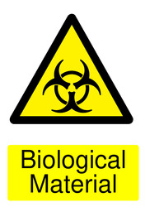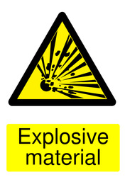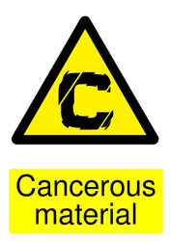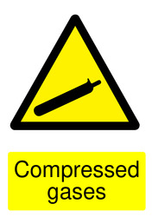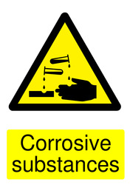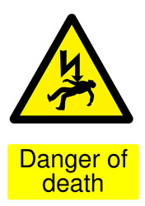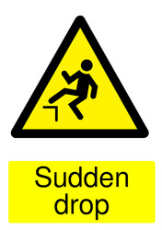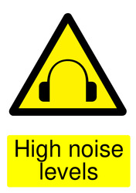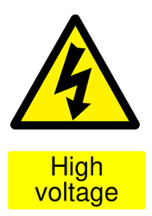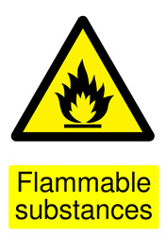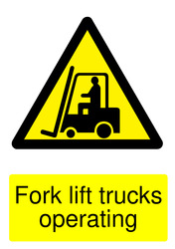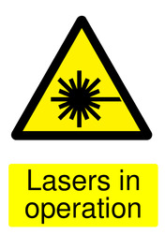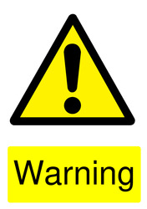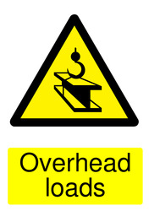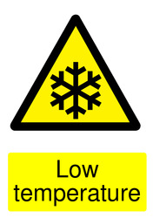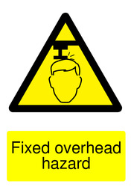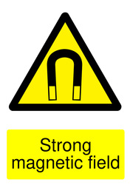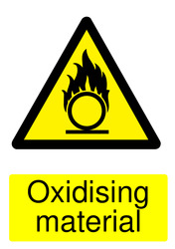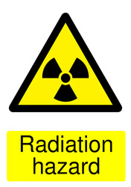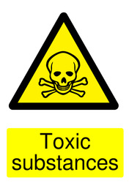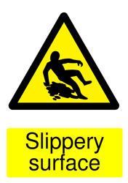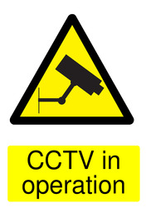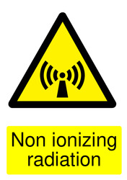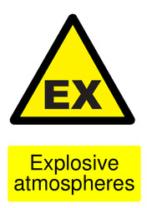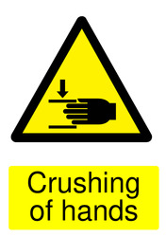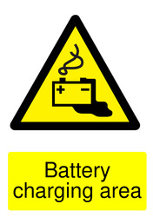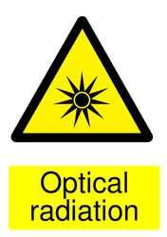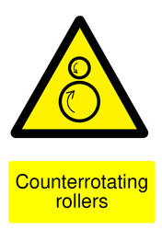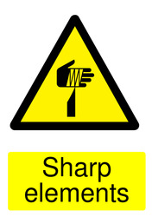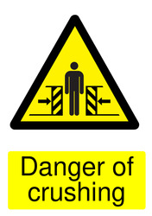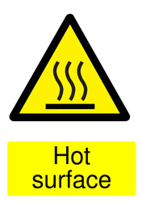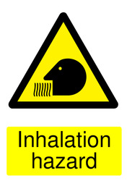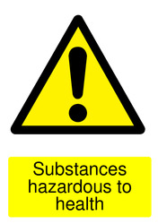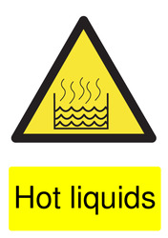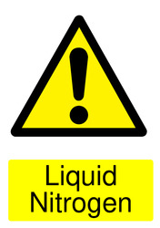
Prohibition signs
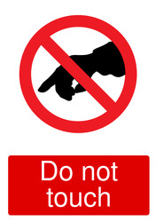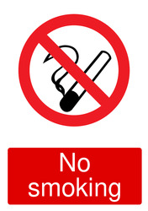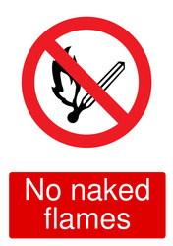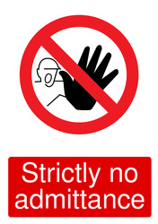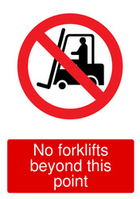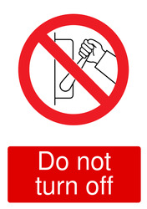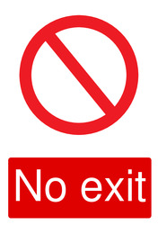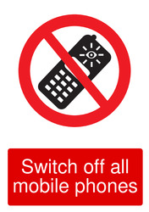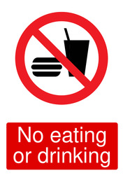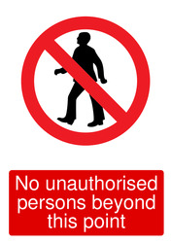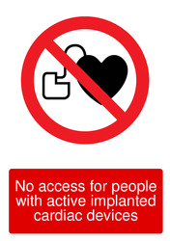

Mandatory signs
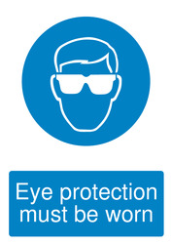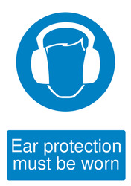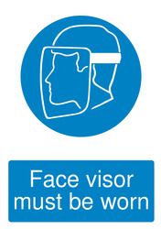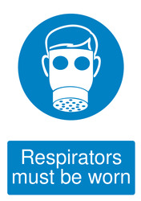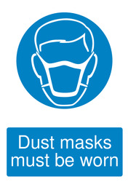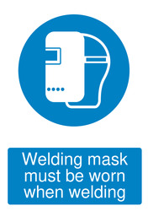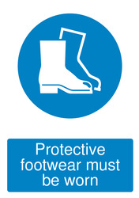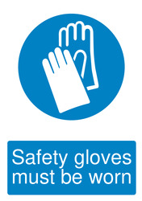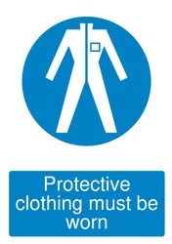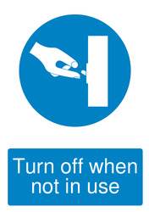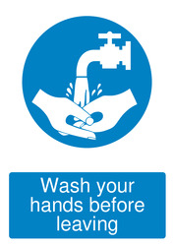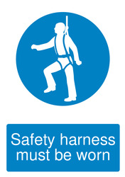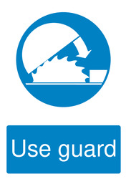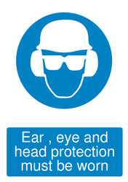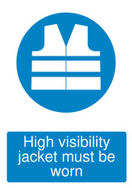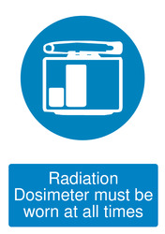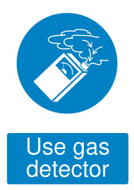

Activity Dependant Signs

